**README FILE**

Data Science And Data Engineering Job Roles Project:

Prathamesh Kulkarni – 001560684

Shreyas Shetty – 002752852

PROJECT DESCRIPTION:

The scope of our project is to create a database that can determine the Data Science and Data engineering roles easily. The main objective of this project is to create a database that can predict the future scope of data science and data engineering roles and cater to the shortage of opportunities available in the market. Since Data science is an evolving field and very crucial to today’s companies and business needs, we want to provide a platform for the students to find their desired job roles by accessing the database. The features such as location, stocks, current salary, years of experience, level, current degree, etc. will be fundamental in determining the job outcome of the individual. By creating this database, we want to streamline a process where students and prospective employees can be made aware of the data science and data engineering roles available in the future.

We were working in the capacity where we cleaned and modified the data available. This database project aims to solve the everlasting issue of job search in the field of Data science and data engineering.

STEPS FOLLOWED IN BEFORE GETTING THE FINAL DATABASE:

1) Firstly, we used the twitter URL to get scrape the Data Science and Data engineering job roles data using the Twitter’s Developers account and using the tweepy library. Then we created the Use cases using the scraped data and used python for it. We also executed them in the Jupyter notebook.

2) As a part of second step we used different sources to scrape the data and then merged it into one dataset. We collected 2 datasets from kaggle and scraped data from 2 different sites using web scraping. We then stored the gathered data into 4 tables in SQL Lite. Further we created different Create and Insert Statements which included different types of joins using SQL lite database.

3) Thirdly, we used a different dataset from Kaggle for performing Normalization. That’s because our previous dataset was already in the 1NF, 2NF, 3NF form. Hence, to practice normalization we performed the 1NF, 2NF and 3NF operations on the new dataset and brought the data into desired format. We also created the VIEW statements in SQL lite to execute al the use cases from the previous assignments.

4) Lastly, we switched to the original database gathered in Step 2 and performed the 1NF and 2NF operations. We also performed data visualization on the dataset and plotted different graphs such as line graph, box plot, violin graph and pie chart to display the data.

Use Cases from Twitter Web Scraping:

1) Use Case: Display tweets searched by a keyword "Job". Description: User can view tweets containing the job keyword

Actor: User

Precondition: When a user wants to search tweets using a specific keyword.

Steps: 'Select * from twitter_bot where Tweet like "%Job%" ', con = conn

Actor action: User views tweets containing keyword Job.

System Responses: The list of tweets with the keyword Job is displayed.

Post Condition:User successfully views the tweets with the keyword Job.

Alternate Path: The are no tweets with keyword Job available to display.

Error: Tweets searched by keyword "Job" do not exist.

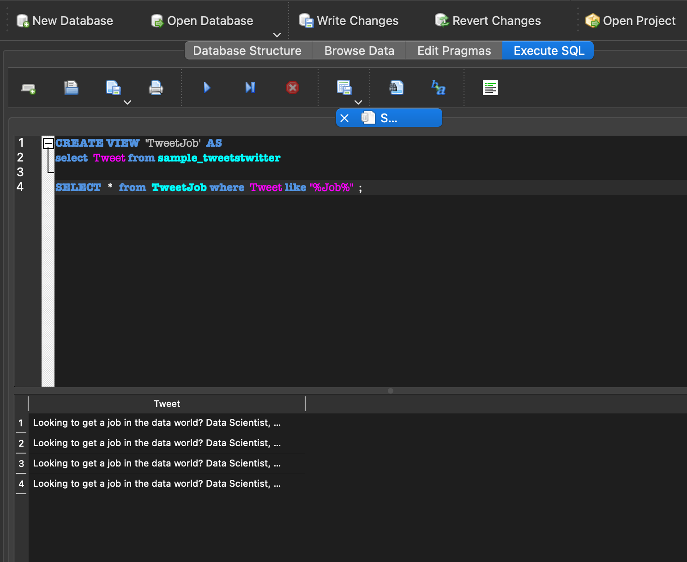

2)Use Case: View the tweets above a specific number of likes (say 20)

Description: Use tweets above a specific number of likes Actor:

User Precondition: Steps: 'select *, max(Number_of_Likes) from twitter_bot',con=conn

Actor action: User views tweets above a specific number of likes.

System Responses: The list of tweets above a specific number of likes are displayed

Post Condition: system displays the list of tweets above a specific number of likes.

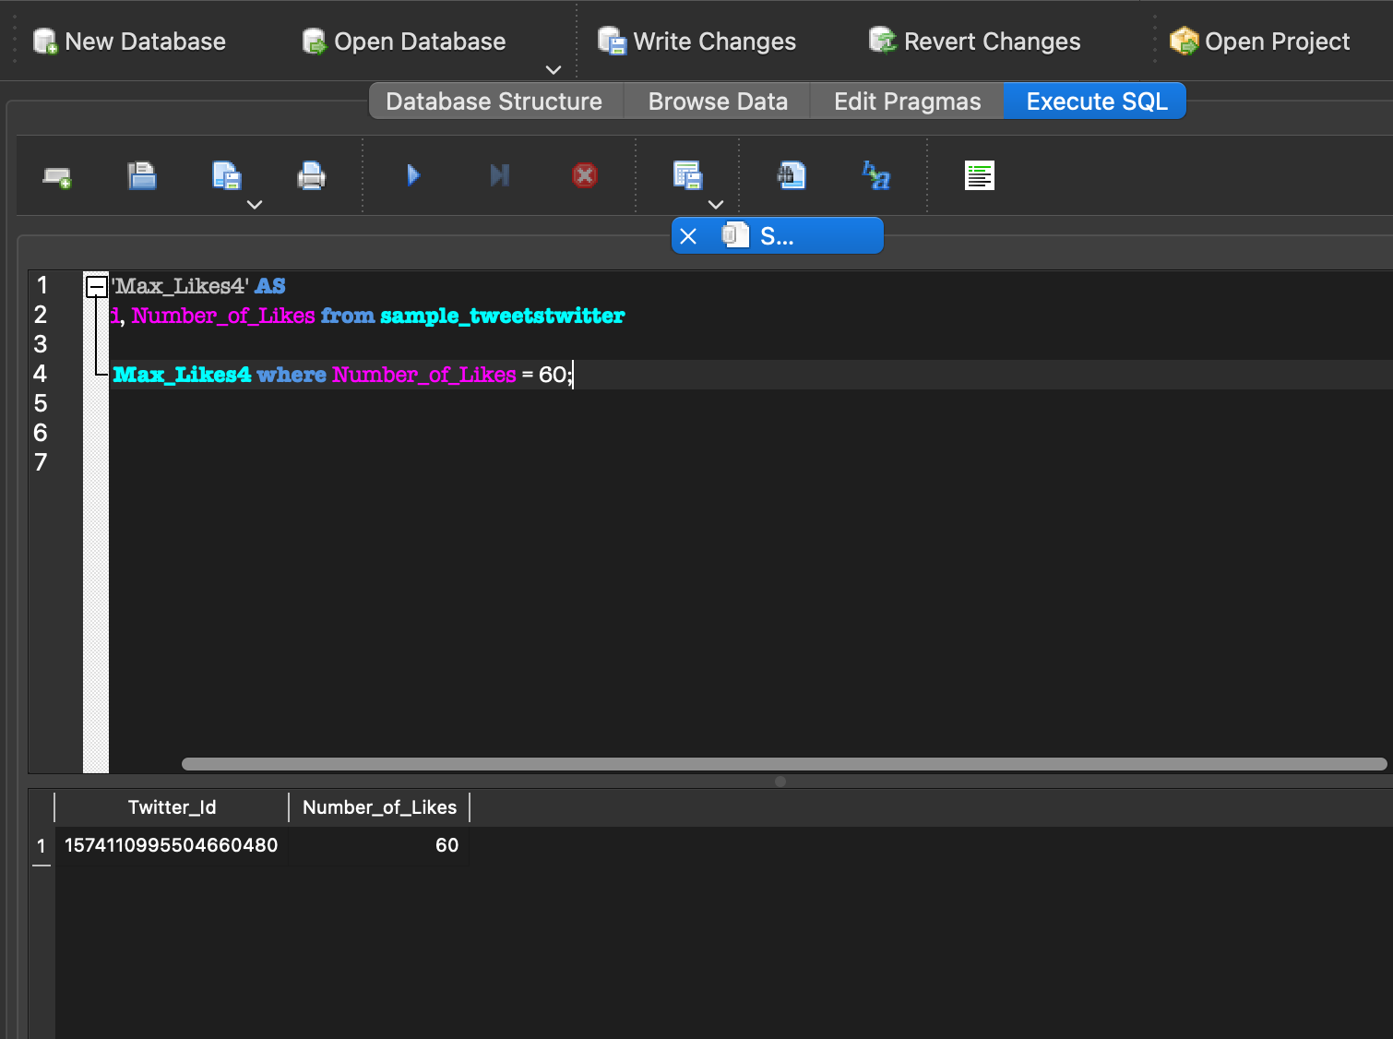

3) Use Case:Display the tweets on a specific date (22 - 11 -04). Description: User can view the tweets posted on (22 - 11 -04).

Actor: User

Precondition: When a user wants to search tweets posted on (22 - 11 -04).

Steps: 'select Tweet,Number_of_Likes, Twitter_Id from twitter_bot where Date_Created_On like "2022-11-04%"'

Actor action: User views the tweets posted on (22 - 11 -04) .

System Responses: Displays all the tweets posted on (22 - 11 -04).

Post Condition: User successfully views all the tweets posted on (22 - 11 -04).

Alternate Path: The are no tweets which are posted on (22 - 11 -04).

Error: Tweets on (22 - 11 -04) do not exist.

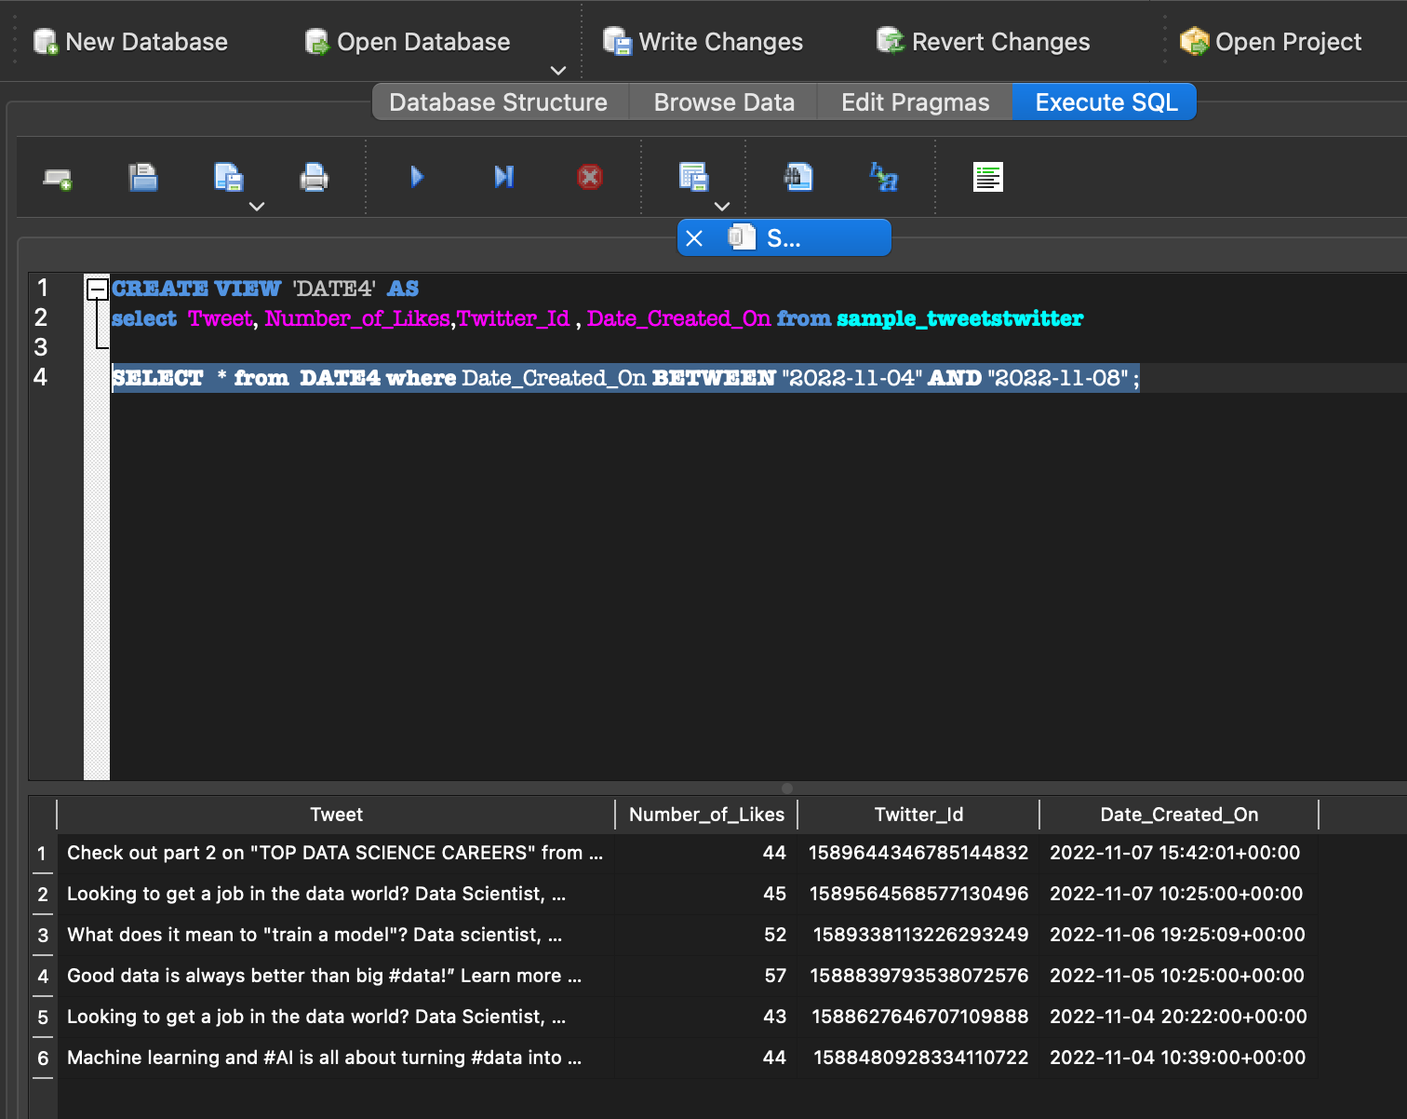

4) Use Case: View the tweets using Tweet ID

Description: User views tweets for a particular Tweet ID

Actor: User Precondition: Twitter ID must exist Steps: 'SELECT * FROM twitter_bot where Twitter_ID = 1588627646707109888', con = conn

Actor action: User views the tweet using the mentioned Tweet ID

System Responses: Displays all the information of that particular Tweet ID

Alternate Path: There is no Tweet ID which is asked

Error: Tweet ID does not exist

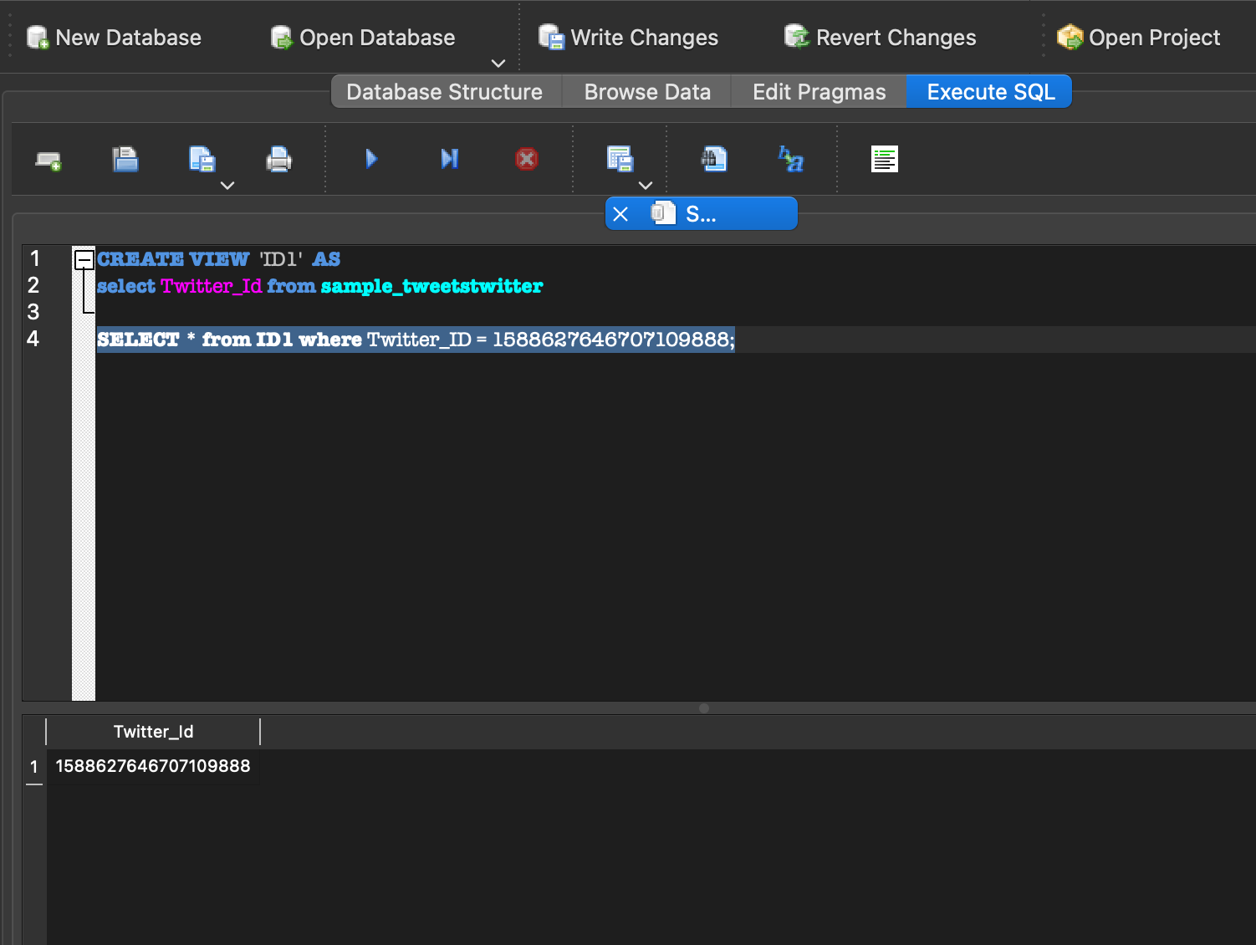

5) Use Case :Display distinct Tweet Description: User can view distinct tweet

Actor: User Precondition: When a user wants to search a distinct number of tweets/ hashtags.

Steps:'select DISTINCT COUNT(*) as Tweet, Source_of_Tweet from twitter_bot GROUP BY Source_of_Tweet', con = conn.

Actor action: User views the distinct tweets.

System Responses: Displays all the distinct tweet information of that particular Tweet/Hashtag.

Alternate Path: The are no distinct tweets available to display.

Error: Distinct tweets do not exist.

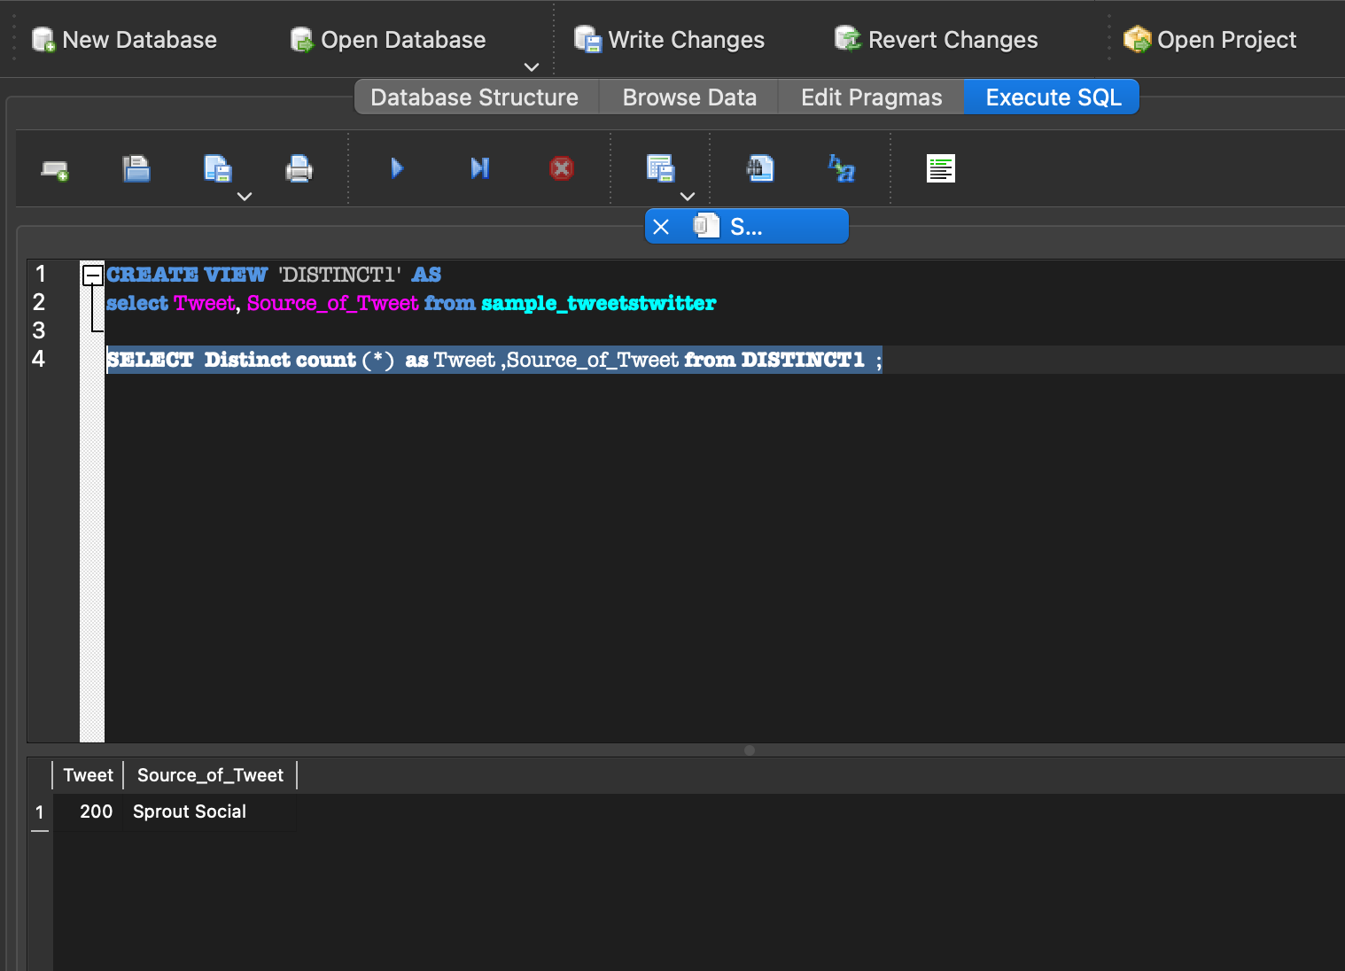

6) Use Case:Display tweets arranged by language. Description: User can view tweets arranged by language.

Actor: User

Precondition: When a user wants to search tweets arranged by language.

Steps: 'Select * from twitter_bot order by Language', con = conn

Actor action: User views the tweets arranged by language.

System Responses: Displays all tweets arranged by language in an order.

Post Condition: User successfully views the tweets in the language requested.

Alternate Path: The are no tweets which are arranged by language available to display.

Error: Tweets arranged by language do not exist.

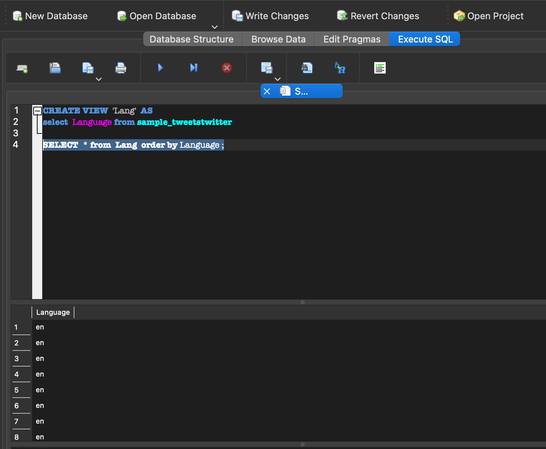

7) Use Case:Display the number of tweets from last 24 hours (2022-11-05) to date (2022-11-07) . Description: User can view the number of tweets from last 24 hours (2022-11-05) to (2022-11-07).

Actor: User

Precondition: When a user wants to search the number of tweets from the last 24 hours (2022-11-05) to (2022-11-07).

Steps: 'select count(Date_Created_On) ,Name from twitter_bot where Date_Created_On BETWEEN "2022-11-05" AND "2022-11-07" group by Name', con = conn

Actor action: User views the total number of tweets from the last 24 hours(2022-11-05) to (2022-11-07).

System Responses: Displays the number of tweets from the last 24 hours(2022-11-05) to (2022-11-07).

Post Condition: User successfully views the number of tweets from the last 24 hours(2022-11-05) to (2022-11-07).

Alternate Path: The are no tweets from the last 24 hours(2022-11-05) to (2022-11-07) available to display.

Error: Tweets from the last 24 hours (2022-11-05) to (2022-11-07) do not exist.

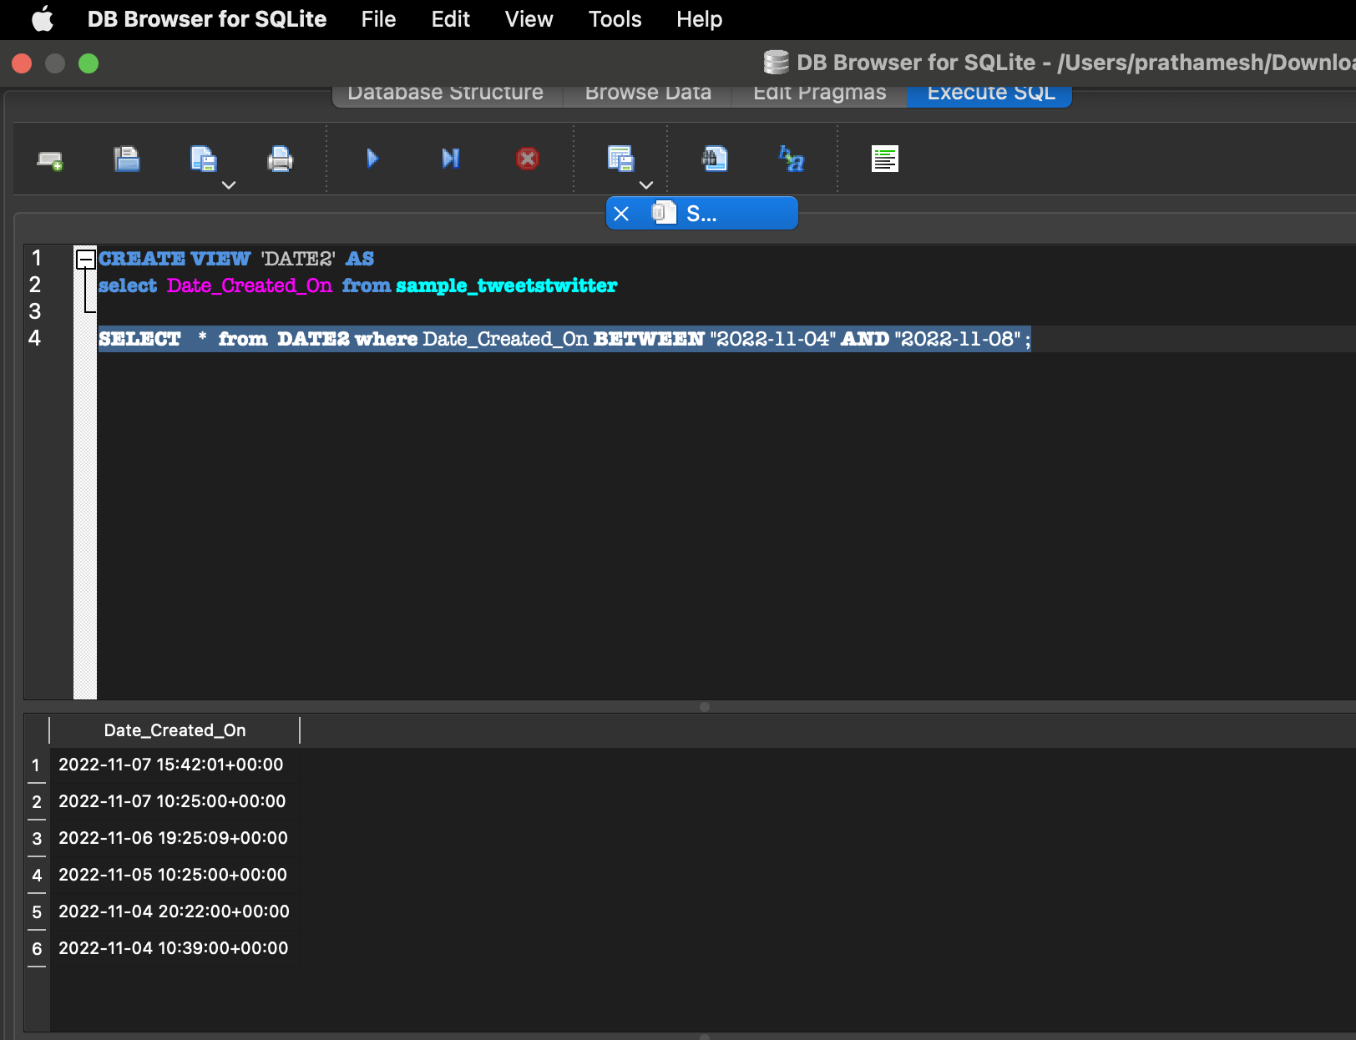

8) Use Case:Display the tweets from last 24 hours (2022-11-05) to date (2022-11-07). Description: User can view the tweets from the last 24 hours (2022-11-05) to (2022-11-07).

Actor: User

Precondition: When a user wants to search tweets from the last 24 hours (2022-11-05) to (2022-11-07).

Steps: 'select Tweet , Name from twitter_bot where Date_Created_On BETWEEN "2022-11-05" AND "2022-11-07" group by Name', con = conn

Actor action: User views the tweets from the last 24 hours (2022-11-05) to (2022-11-07).

System Responses: Displays all tweets from the last 24 hours (2022-11-05) to (2022-11-07).

Post Condition: User successfully views all the tweets from the last 24 hours (2022-11-05) to (2022-11-07).

Alternate Path: The are no tweets which are from the last 24 hours (2022-11-05) to (2022-11-07) available to display.

Error: Tweets from the last 24 hours (2022-11-05) to (2022-11-07) do not exist.



9) Use Case:Display the tweets that have the some other users mentioned. Description: User can view the tweets that have the some other users mentioned for eg "@John".

Actor: User

Precondition: When a user wants to search tweets that have the some other users mentioned for eg "@".

Steps: 'select * from twitter_bot where Tweet like "%@%" ', con = conn

Actor action: User views the tweets that have the some other users mentioned for eg "@".

System Responses: Displays all tweets that have the some other users mentioned for eg "@".

Post Condition: User successfully views all the tweets that have the some other users mentioned for eg "@".

Alternate Path: The are no tweets that have the some other users mentioned for eg "@".

Error: Tweets with mentions for eg "@"do not exist.



10 ) Use Case:Display the tweets that have the Source_Tweet as Sprout_Social and ordered by language. Description: User can view the tweets that have the Source_Tweet as Sprout_Social and ordered by language.

Actor: User

Precondition: When a user wants to search tweets have the Source_Tweet as Sprout_Social and ordered by language.

Steps: 'Select Name from twitter_bot where Source_of_Tweet is "Sprout Social" order by Language', con = conn'

Actor action: User views the tweets that have the Source_Tweet as Sprout_Social and ordered by language.

System Responses: Displays all tweets that have the Source_Tweet as Sprout_Social and ordered by language.

Post Condition: User successfully views all the tweets that have the Source_Tweet as Sprout_Social and ordered by language.

Alternate Path: The are no tweets that have the Source_Tweet as Sprout_Social and ordered by language.

Error: Tweets with Source_Tweet as Sprout_Social and ordered by language do not exist.

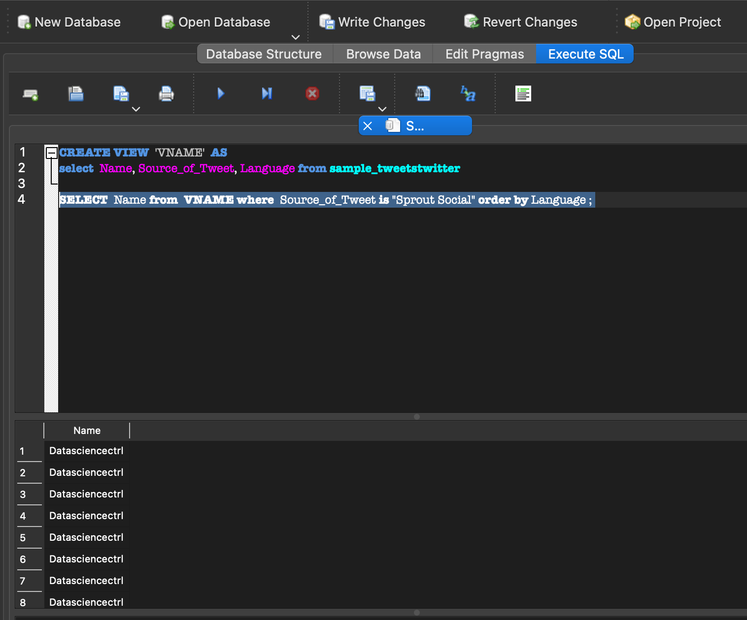

USE CASES FROM ASSIGNMENT 3 (MUNGING, CLEANNG AND SCRAPING DATA )

1) Use Case: Display tweets searched by company and Job Type. Description: User can view data containing company and Job Type.

Actor: User

Precondition: When a user wants to search data using company and Job Type.

Steps:('select c.Company,o.Jobtype from InitialScraping_1 c inner join DMDD_Assignment3 o on c.Company = o.Company',con = conn )

Actor action: User views data containing company and Job Type.

System Responses: The list of data with tcompany and Job Type are displayed.

Post Condition:User successfully views the data with company and Job Type.

Alternate Path: There is no data with keyword Job available to display.

Error: Data searched by company and Job Type do not exist.

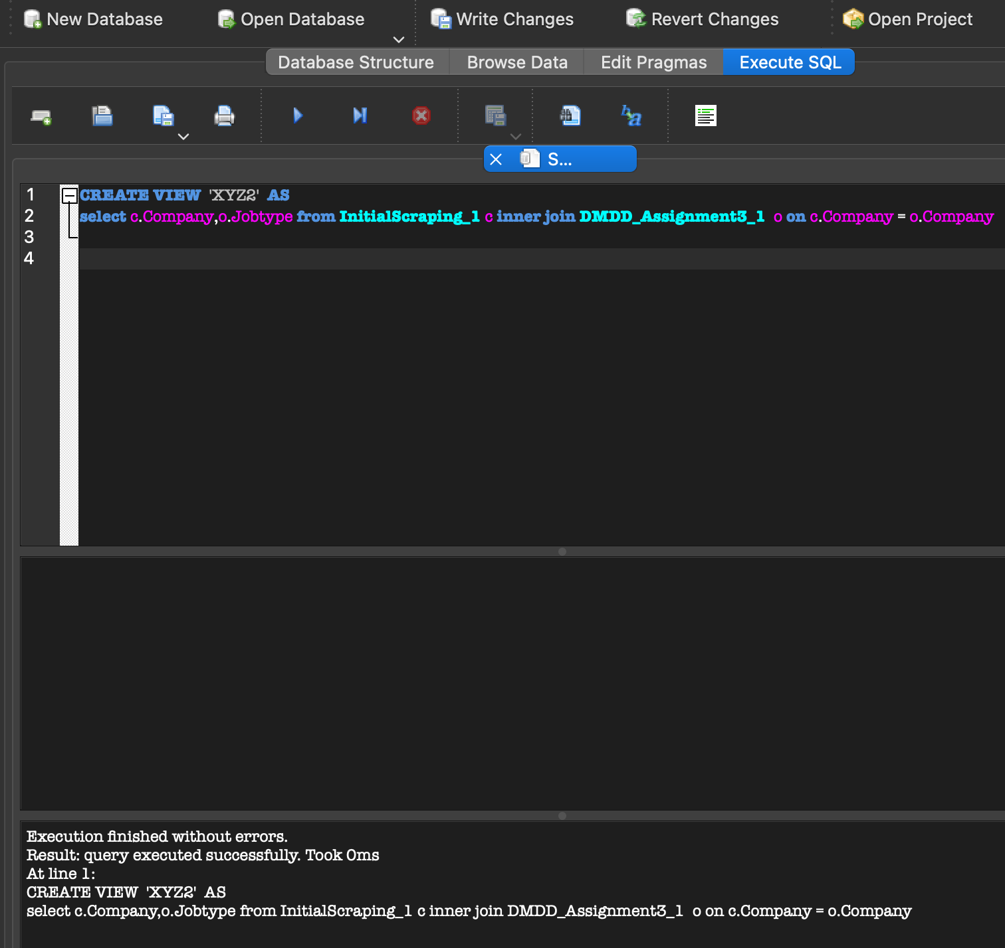

2) Use Case: Display data grouped by level. Description: User can view data containing Level and Job Type grouped by Level.

Actor: User

Precondition: When a user wants to search containing Level and Job Type grouped by Level.

Steps:df34 = ('select c.Jobtype,o.Level from InitialScraping_1 c left join DMDD_Assignment3 o on c.Company= o.Company ORDER BY c.Level', con = conn )

Actor action: User views data containing Level and Job Type grouped by Level.

System Responses: The list of data containing Level and Job Type grouped by Level are displayed.

Post Condition:User successfully views the data containing Level and Job Type grouped by Level.

Alternate Path: There is no data containing Level and Job Type grouped by Level available to display.

Error: Data data containing Level and Job Type grouped by Level do not exist.

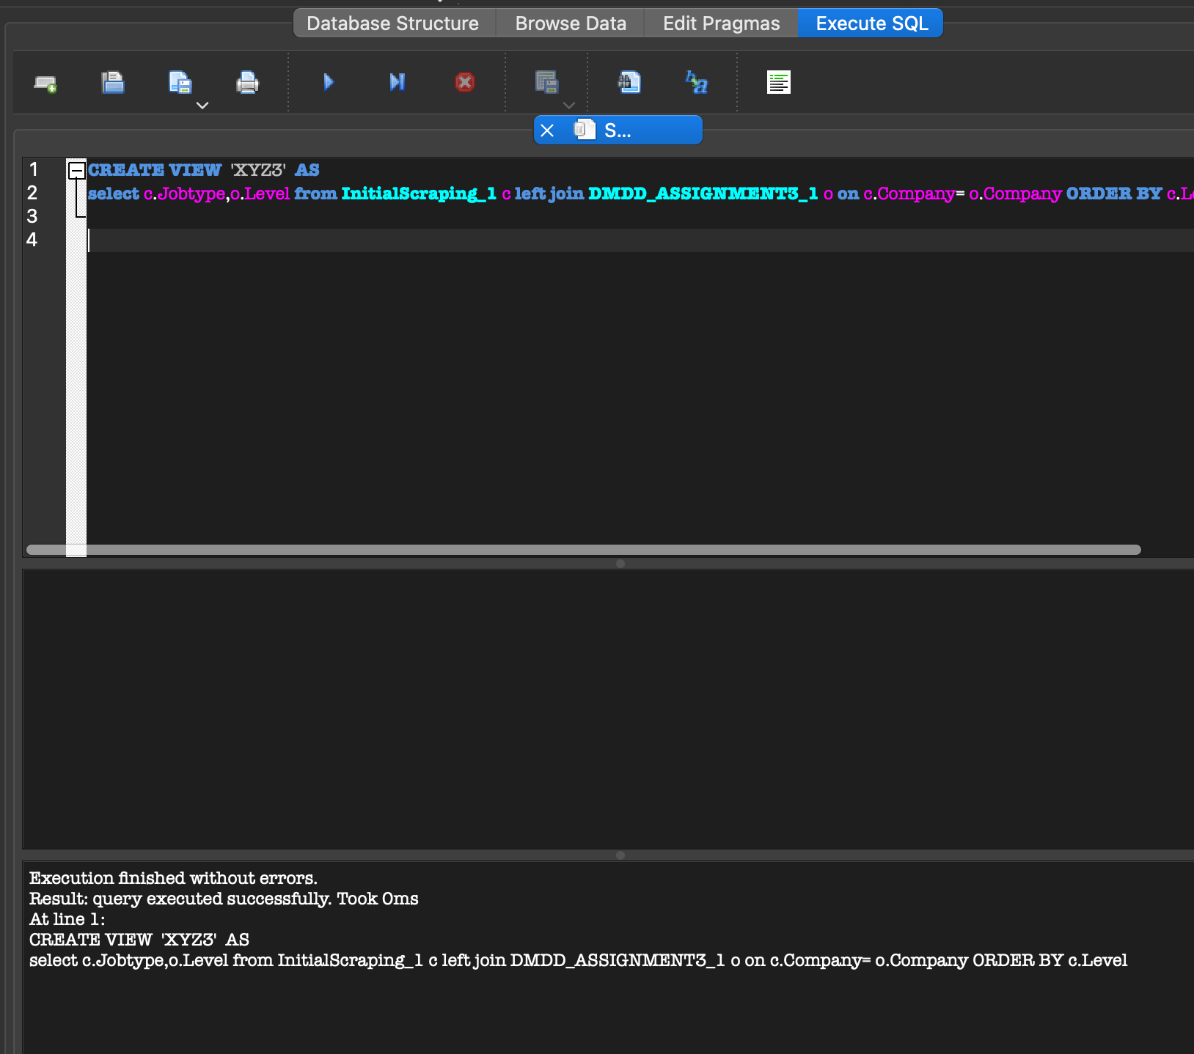

3) Use Case: Display data containing job type and location grouped by location . Description: User can view data containing job type and location grouped by location.

Actor: User

Precondition: When a user wants to search data containing job type and location grouped by location.

Steps: ('select c.Jobtype,o.Location from InitialScraping_1 c right join DMDD_Assignment3 o on c.Company= o.Company ORDER BY c.Location',con = conn )

Actor action: User views data containing job type and location grouped by location.

System Responses: The list of data containing containing job type and location grouped by location are displayed.

Post Condition:User successfully views the data containing job type and location grouped by location.

Alternate Path: There is no data containing containing job type and location grouped by location available to display.

Error: Data data containing job type and location grouped by location do not exist.

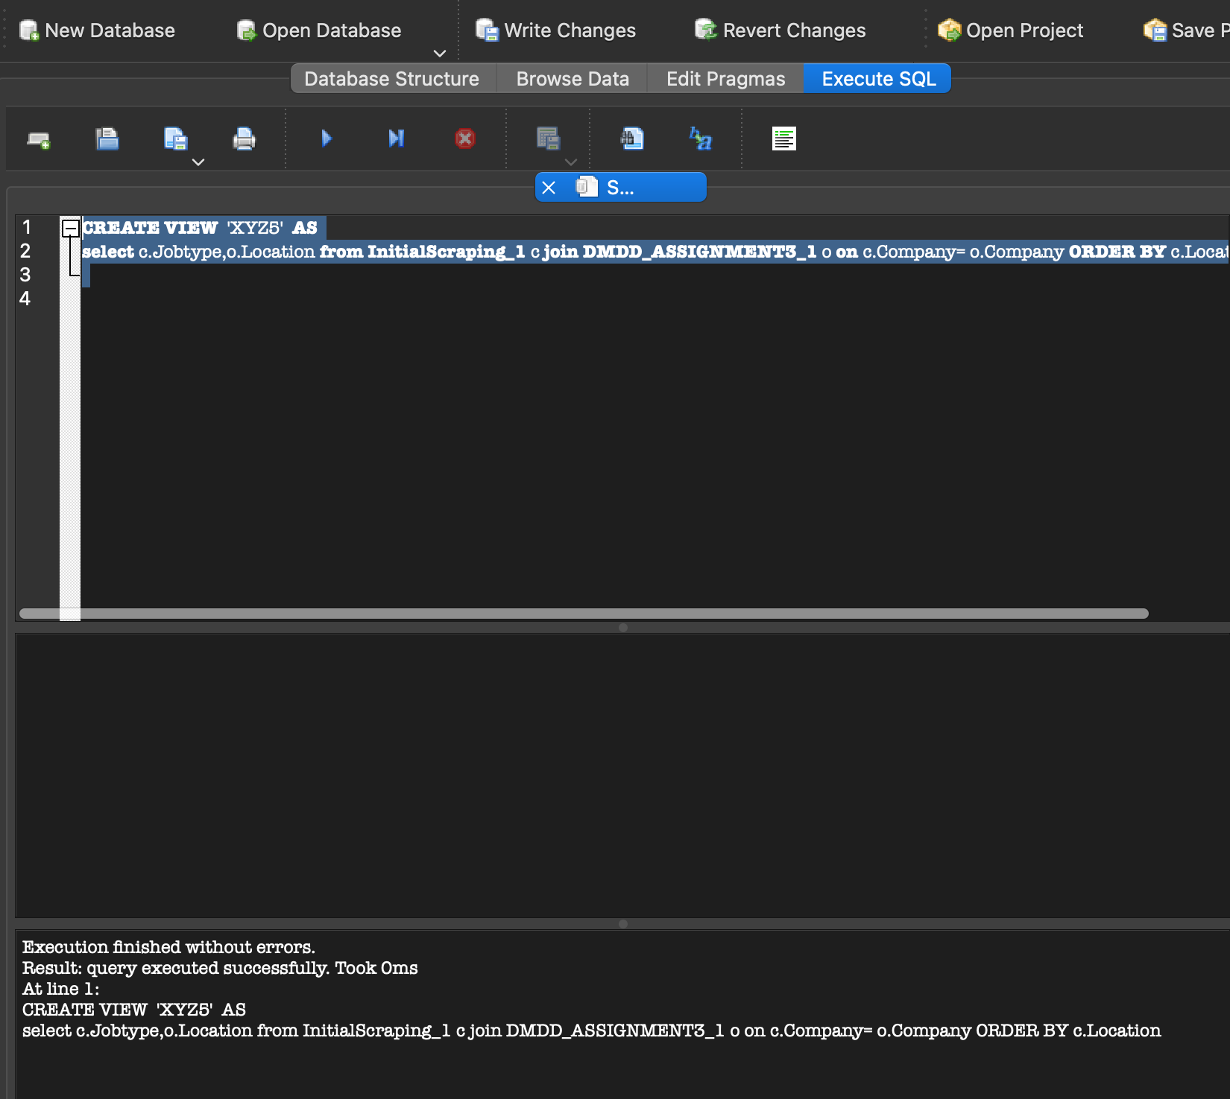

4) Use Case: Display data containing Company and job type grouped by Company. Description: User can view data containing Company and job type grouped by Company.

Actor: User

Precondition: When a user wants to search data containing Company and job type grouped by Company.

Steps: ('select c.Company,o.Jobtype from InitialScraping_1 c right join DMDD_Assignment3 o on c.Company= o.Company ORDER BY c.Company',con = conn )

Actor action: User views data containing Company and job type grouped by Company.

System Responses: The list of data containing Company and job type grouped by Company.

Post Condition:User successfully views the data containing Company and job type grouped by Company.

Alternate Path: There is no data containing containing Company and job type grouped by Company available to display.

Error: Data data containing Company and job type grouped by Company do not exist.

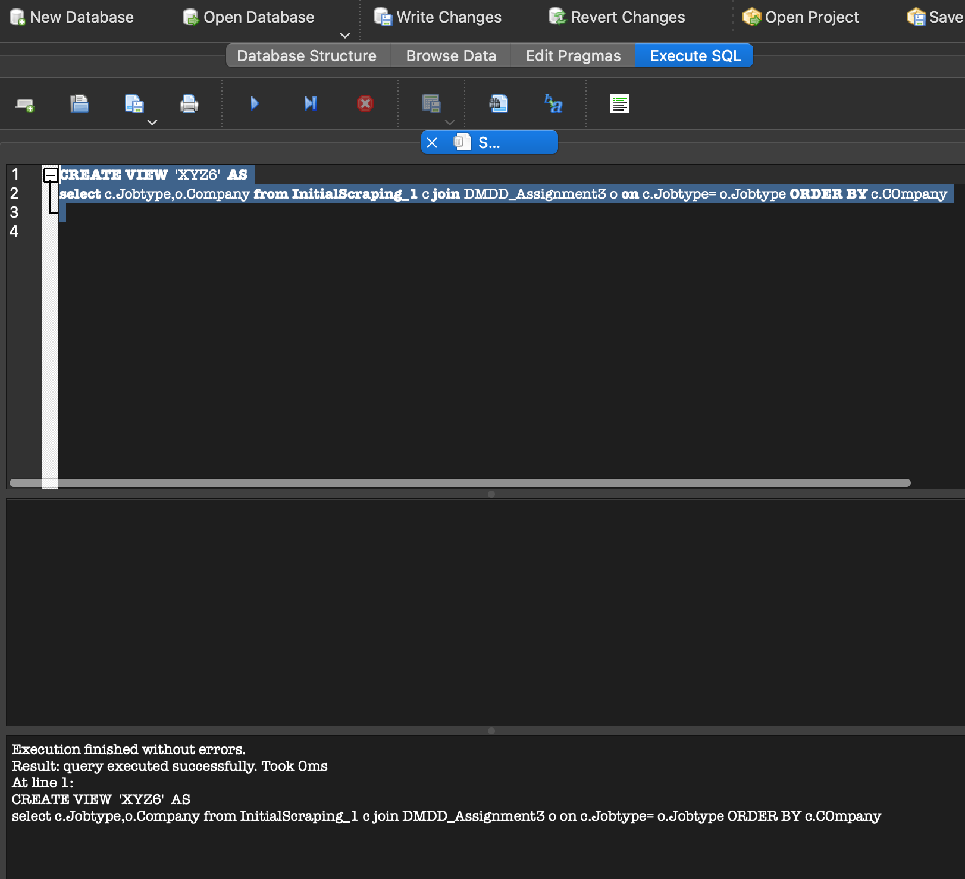

5) Use Case: Display data containing Company and Level. Description: User can view data containing Company and Level.

Actor: User

Precondition: When a user wants to search data containing Company and Level.

Steps:('select c.Level,c1.Company from InitialScraping_1 c, InitialScraping_1 c1 where c.Jobtype= c1.Jobtype',con = conn )

Actor action: User views data containing Company and Level.

System Responses: The list of data containing Company and Level.

Post Condition:User successfully views the data containing Company and Level.

Alternate Path: There is no data containing Company and Level to display.

Error: Data data containing Company and Level do not exist.

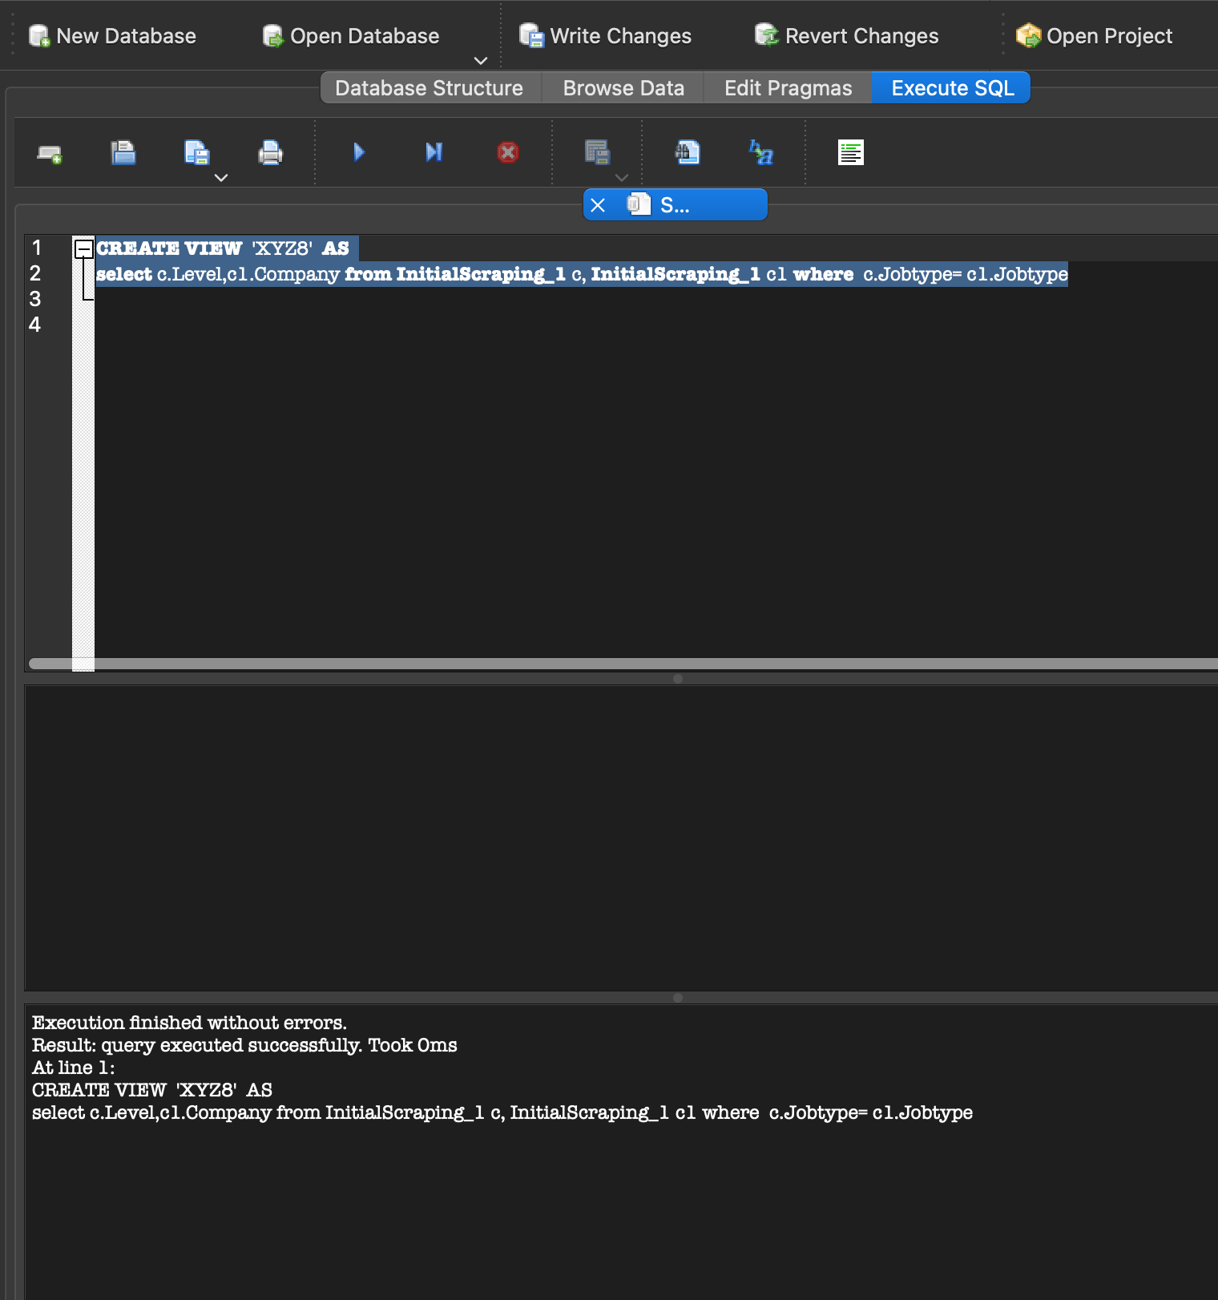

6) Use Case: Display data containing Job Title and Salary . Description: User can view data containing Job Title and Salary .

Actor: User

Precondition: When a user wants to search data containing Job Title and Salary .

Steps:('select c.job_title,c1.salary from Scraping3_1 c, Scraping3_1 c1 where c.salary= c1.salary',con = conn )

Actor action: User views data containing Job Title and Salary .

System Responses: The list of data containing Job Title and Salary .

Post Condition:User successfully views the data containing Job Title and Salary .

Alternate Path: There is no data containing Job Title and Salary to display.

Error: Data data containing Job Title and Salary do not exist.

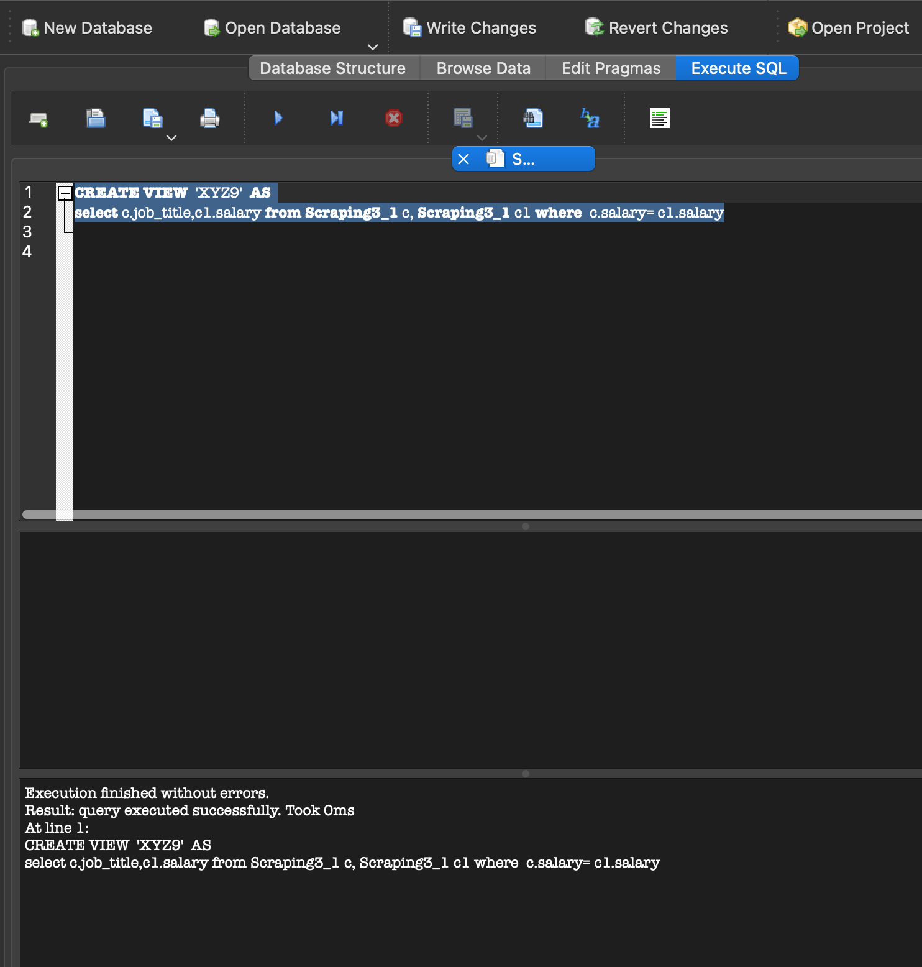

7) Use Case: Display data containing Position, Company and Jobtype . Description: User can view data containing Position, Company and Jobtype.

Actor: User

Precondition: When a user wants to search data containing Position, Company and Jobtype .

Steps:'select c.Position,c1.Company, c1.Jobtype from WEBSC_2_1 c, WEBSC_2_1 c1 where c.Position = c1.Position ',con = conn )

Actor action: User views data containing Position, Company and Jobtype.

System Responses: The list of data containing Position, Company and Jobtype.

Post Condition:User successfully views the data containing Position, Company and Jobtype .

Alternate Path: There is no data containing Position, Company and Jobtypeto display.

Error: Data data containing Position, Company and Jobtypedo not exist.

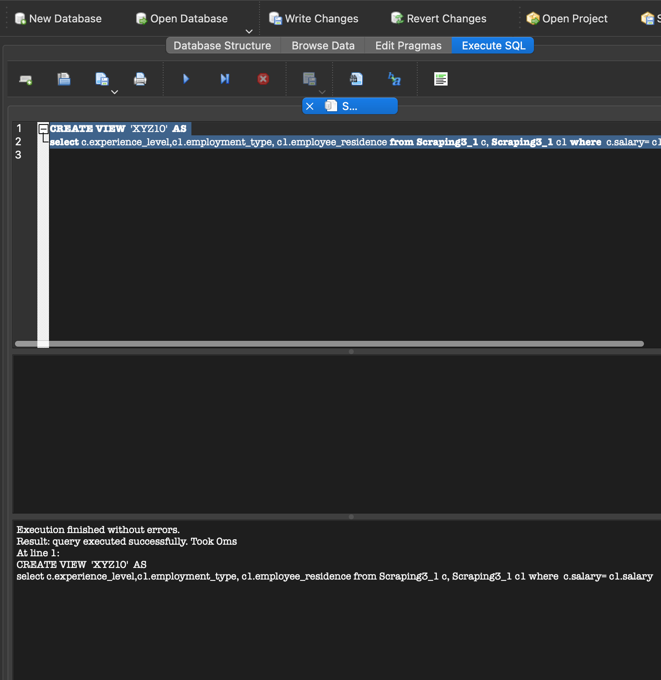

8) Use Case: Display data containing Summary and Jobtype . Description: User can view data containing Summary and Jobtype.

Actor: User

Precondition: When a user wants to search data containing Summary and Jobtype .

Steps:('select c.Jobtype,o.Summary from InitialScraping_1 c left join DMDD_Assignment3 o on c.Company= o.Company',con = conn )

Actor action: User views data containing Summary and Jobtype .

System Responses: The list of data containing Summary and Jobtype .

Post Condition:User successfully views the data containing Summary and Jobtype .

Alternate Path: There is no data containing Summary and Jobtype to display.

Error: Data data containing Summary and Jobtype do not exist.

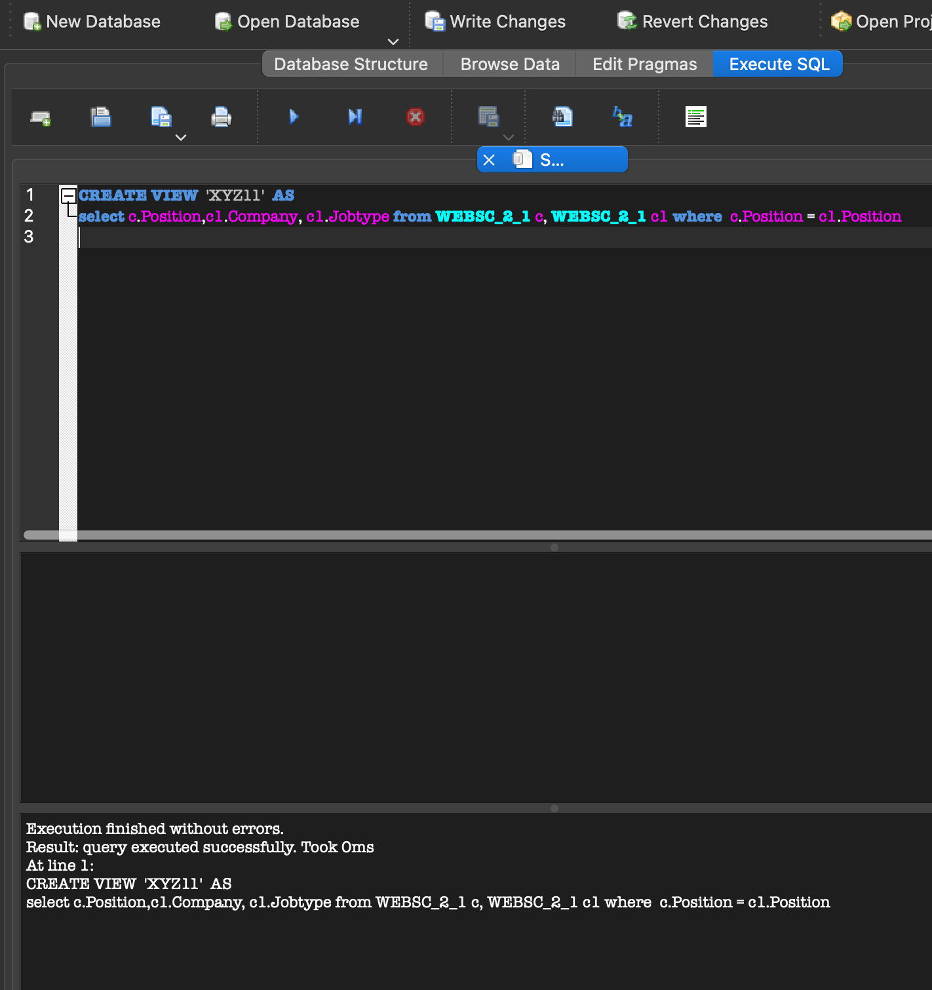

9) Use Case: Display data containing Experience Level, Employment Type and Employee Residence . Description: User can view data Experience Level, Employment Type and Employee Residence .

Actor: User

Precondition: When a user wants to search data containing Experience Level, Employment Type and Employee Residence .

Steps:('select c.experience_level,c1.employment_type, c1.employee_residence from Scraping3_1 c, Scraping3_1 c1 where c.salary= c1.salary',con = conn )

Actor action: User views data containing Experience Level, Employment Type and Employee Residence .

System Responses: The list of data containing Experience Level, Employment Type and Employee Residence .

Post Condition:User successfully views the data containing Experience Level, Employment Type and Employee Residence .

Alternate Path: There is no data containing Experience Level, Employment Type and Employee Residence to display.

Error: Data data containing Experience Level, Employment Type and Employee Residence do not exist.

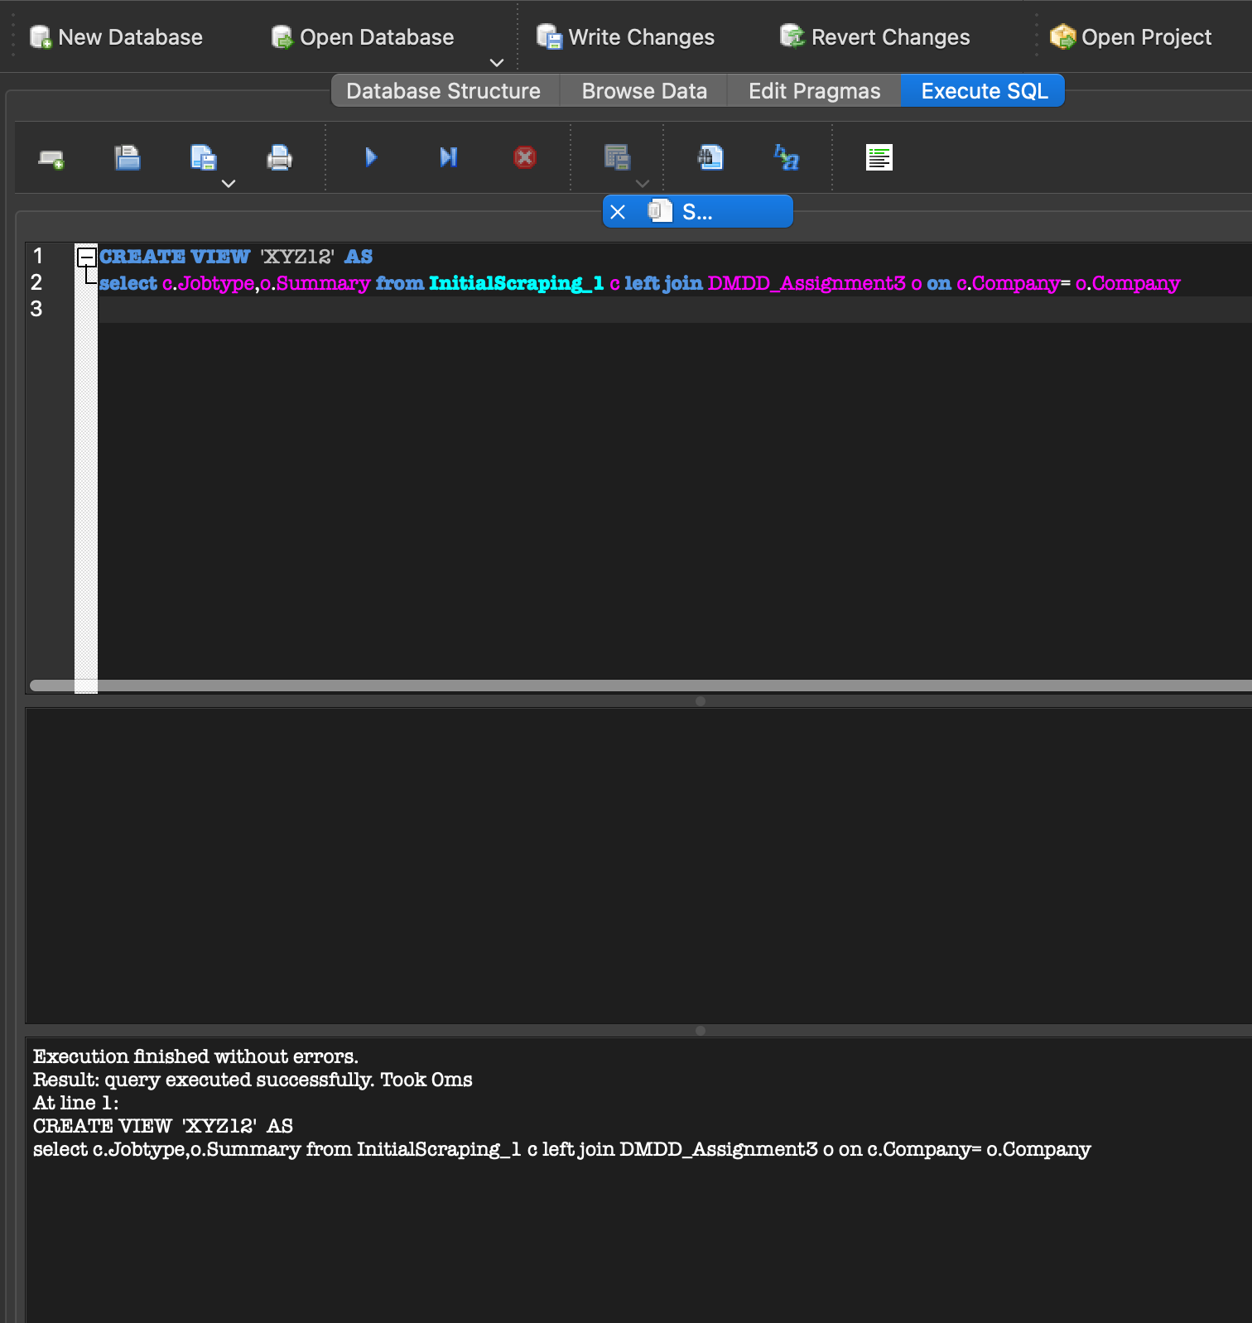

10 ) Use Case: Display data containing Company and Salary. Description: User can view data containing Company and Salary .

Actor: User

Precondition: When a user wants to search data containing Company and Salary.

Steps:('select c.Company,o.Salary from InitialScraping_1 c right join DMDD_Assignment3 o on c.Company= o.Company',con = conn ) Actor action: User views data containing Company and Salary.

System Responses: The list of data containing Company and Salary.

Post Condition:User successfully views the data containing Company and Salary.

Alternate Path: There is no data containing Company and Salary to display.

Error: Data data containing Company and Salary do not exist.

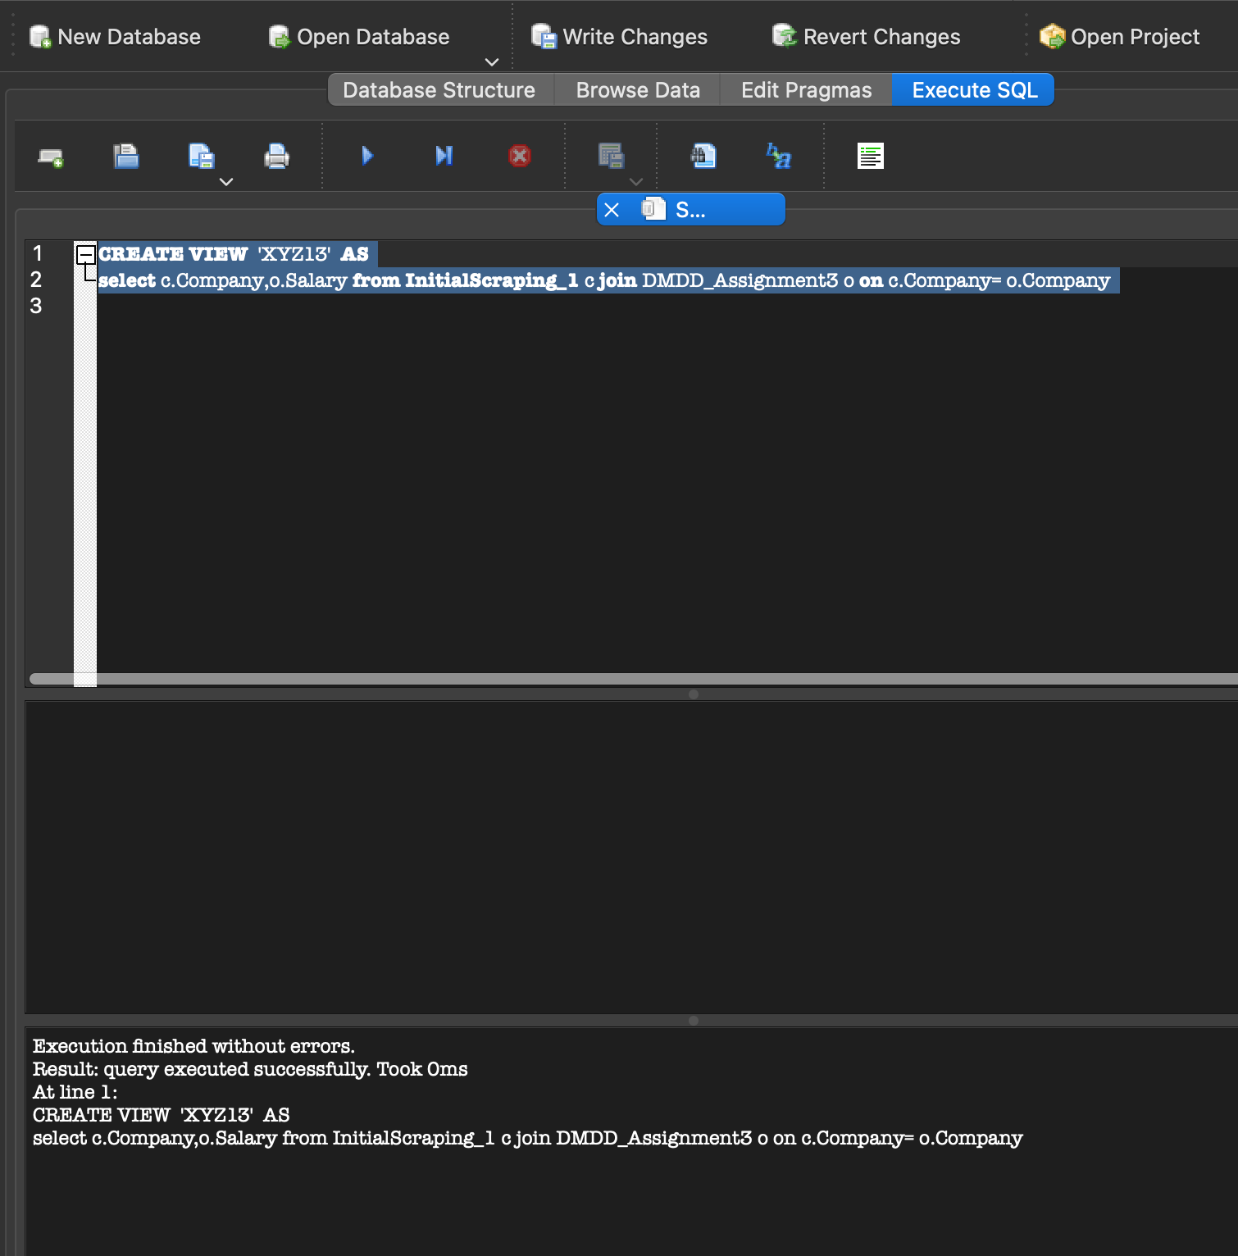

IN ASSIGNMENT 4, WHICH IS NORMALIZATION, OUR DATA WAS ALREADY IN THE 1NF AND 2NF FORM, THAT’S WHY WE DECIDED TO WORK ON A DIFFERENT DATASET AND IN FINAL SUBMISSION WE HAVE WORKED ON OUR PREVIOUS DATASET ONLY. FURTHERMORE, WE HAVE BROUGHT THE DATA IT IN THE REQUIRED 1NF AND 2NF FORMAT AS DISCUSSED IN THE TA HOURS WITH ANKITA.

ORIGINAL DATASET SAMPLE AFTER CLEANING:

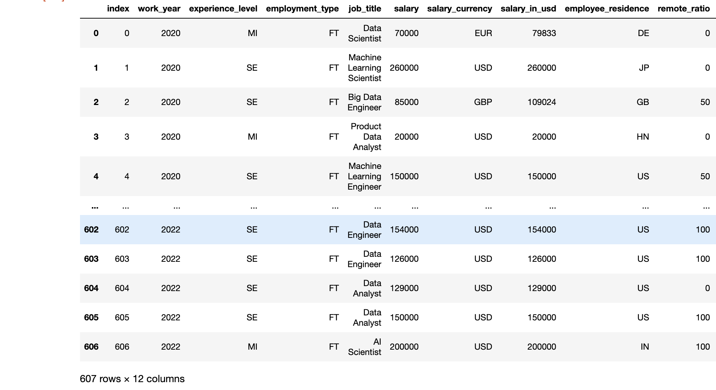

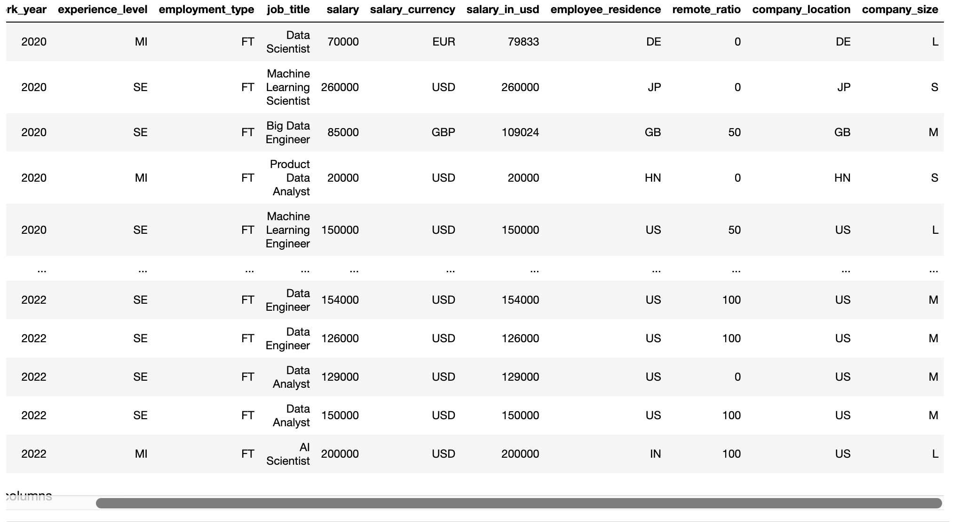

These are the dataset screenshots of the data on which we have performed cleaning, munging and scraping taken from different datasets. Please find attached the screenshots of the of 1NF and 2NF formats which we have created through SQL Lite Databases.

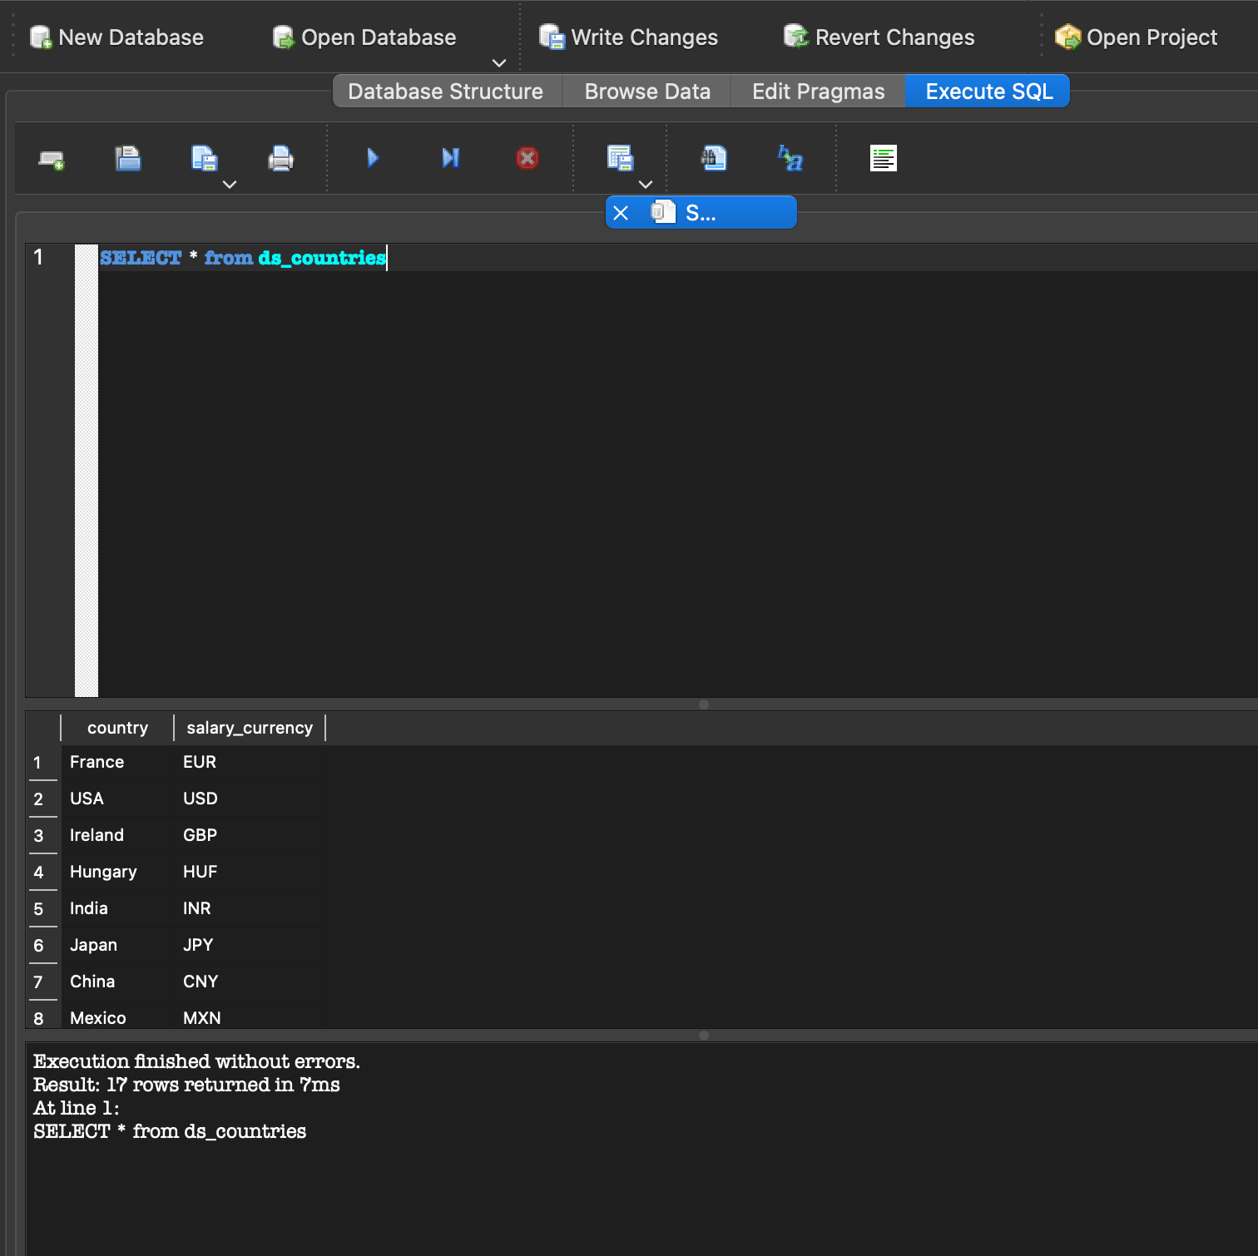

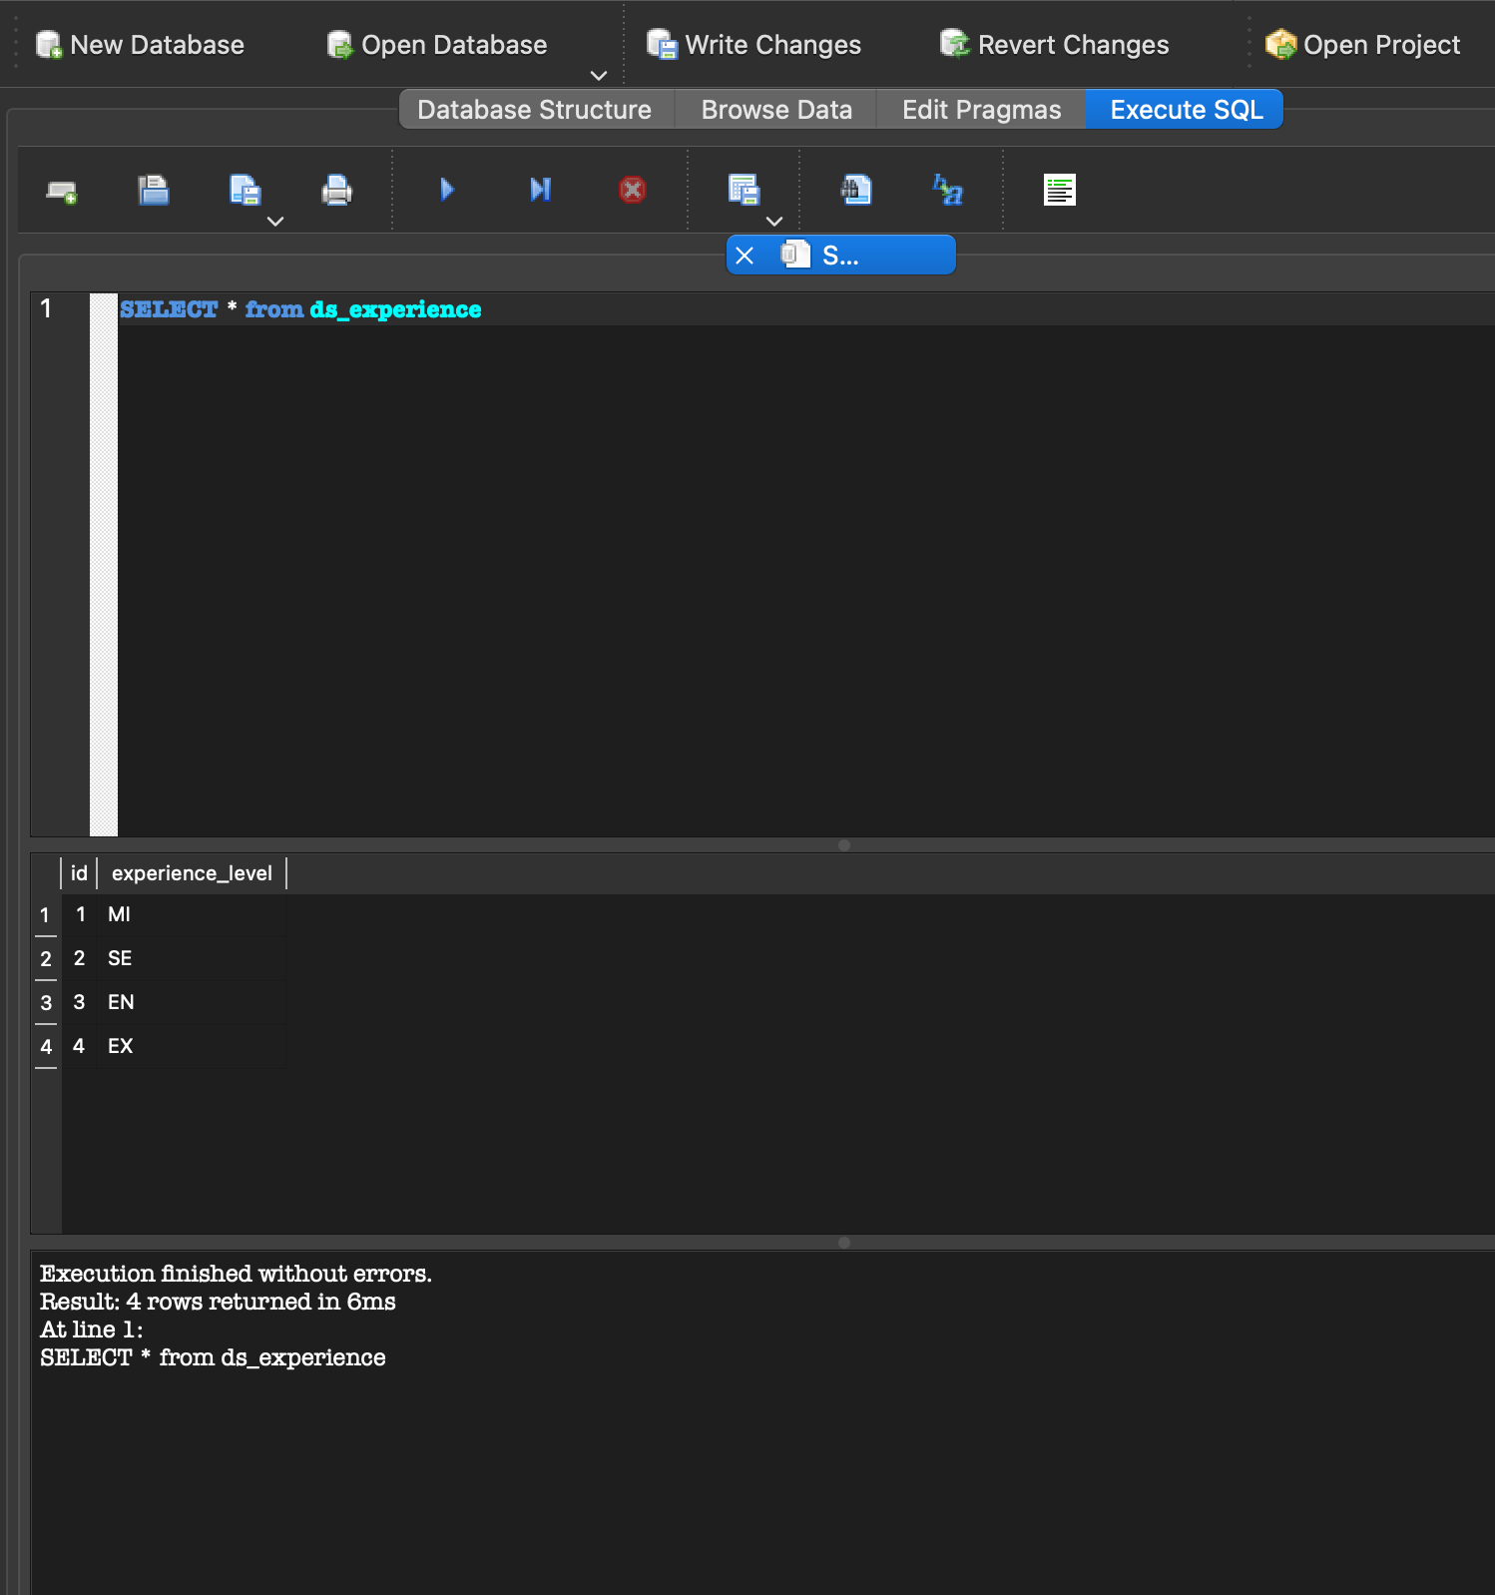

CREATE QUERIES PERFORMED FOR 1NF AND 2NF TABLES:

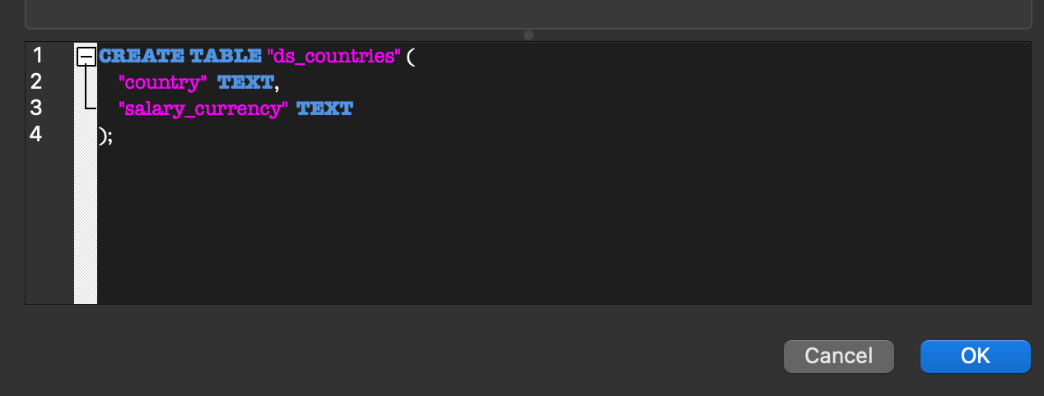

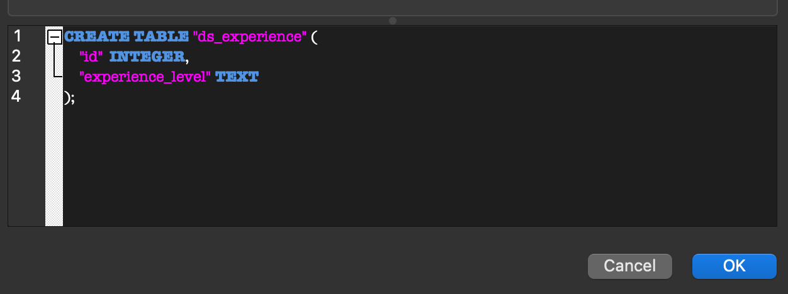

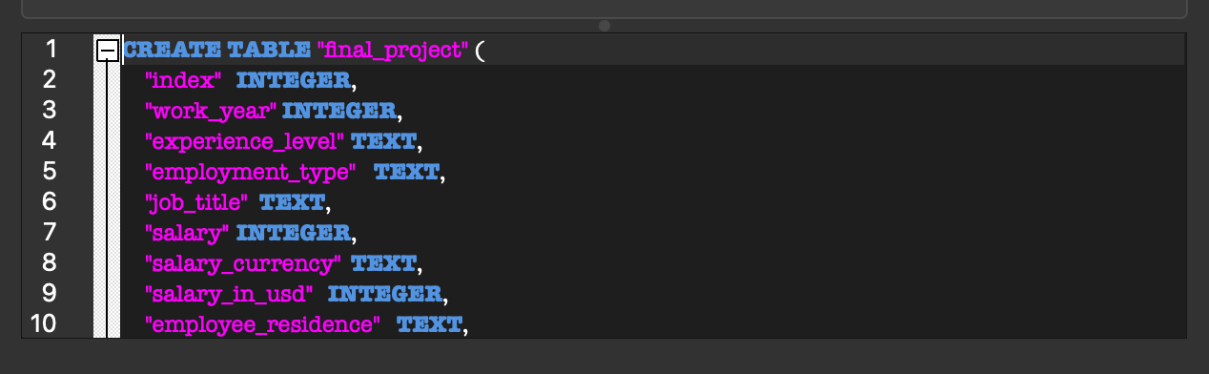

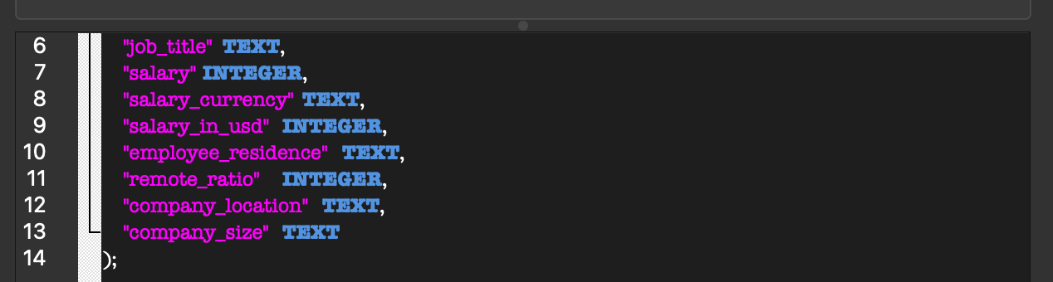

INSERT QUERIES PERFORMED FOR 1NF AND 2NF TABLES:

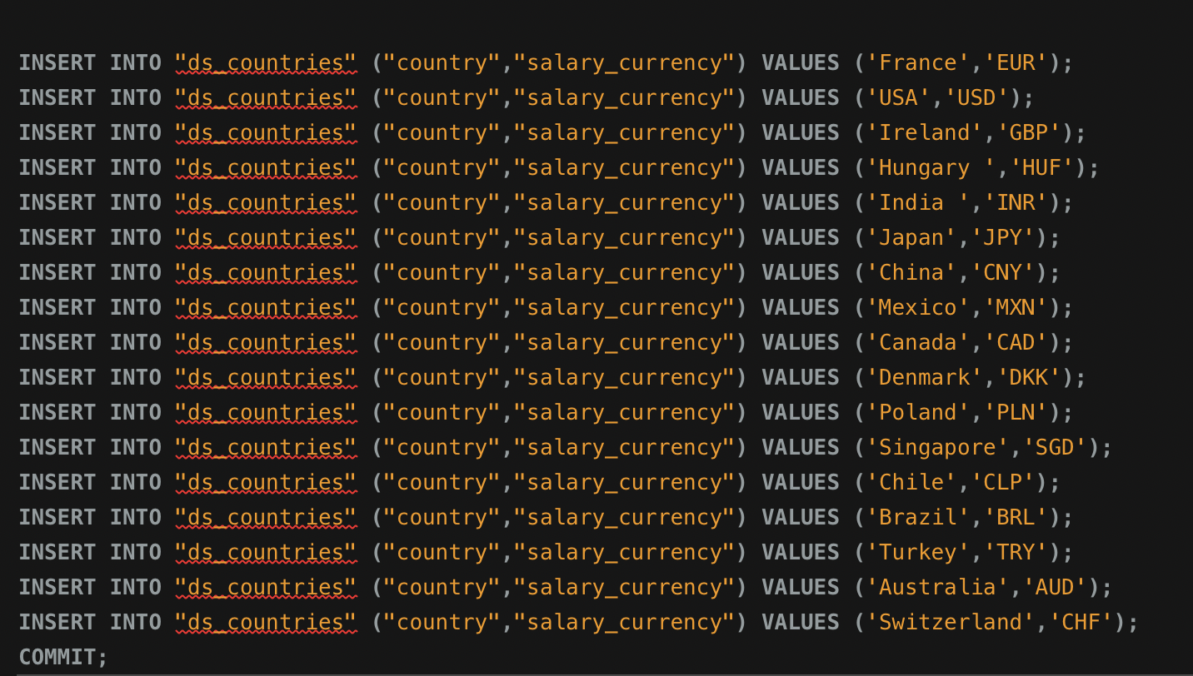

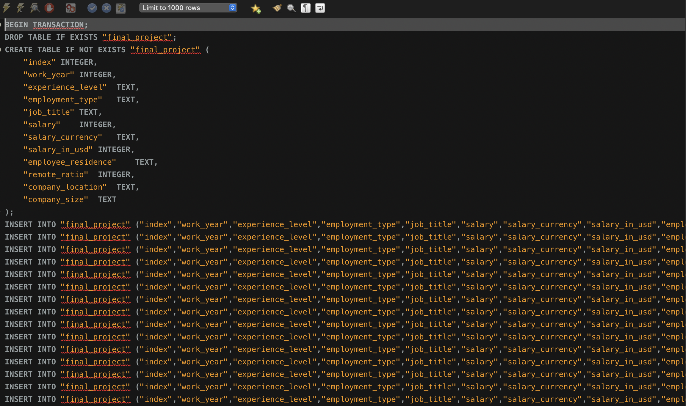

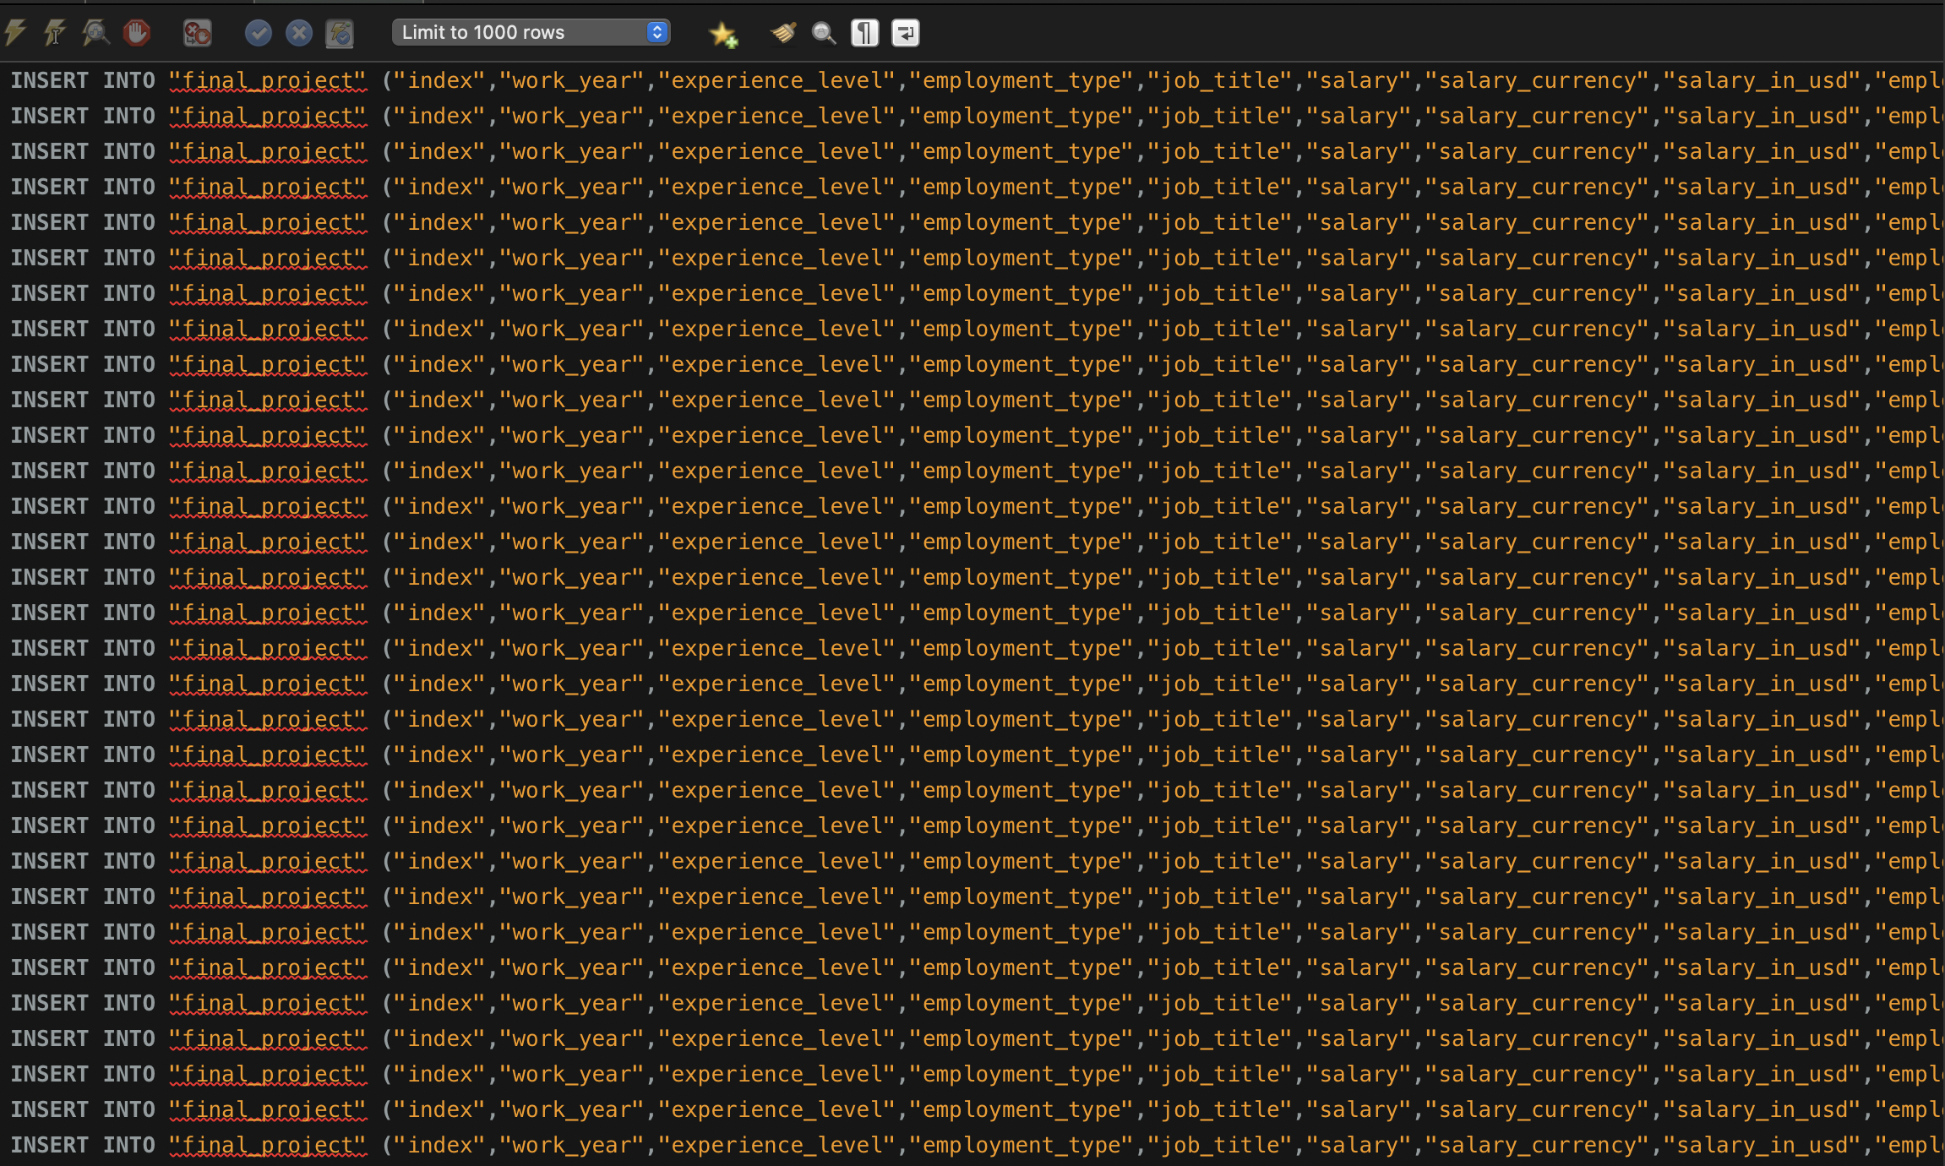

FINAL CONCEPTUAL ER DIAGRAM :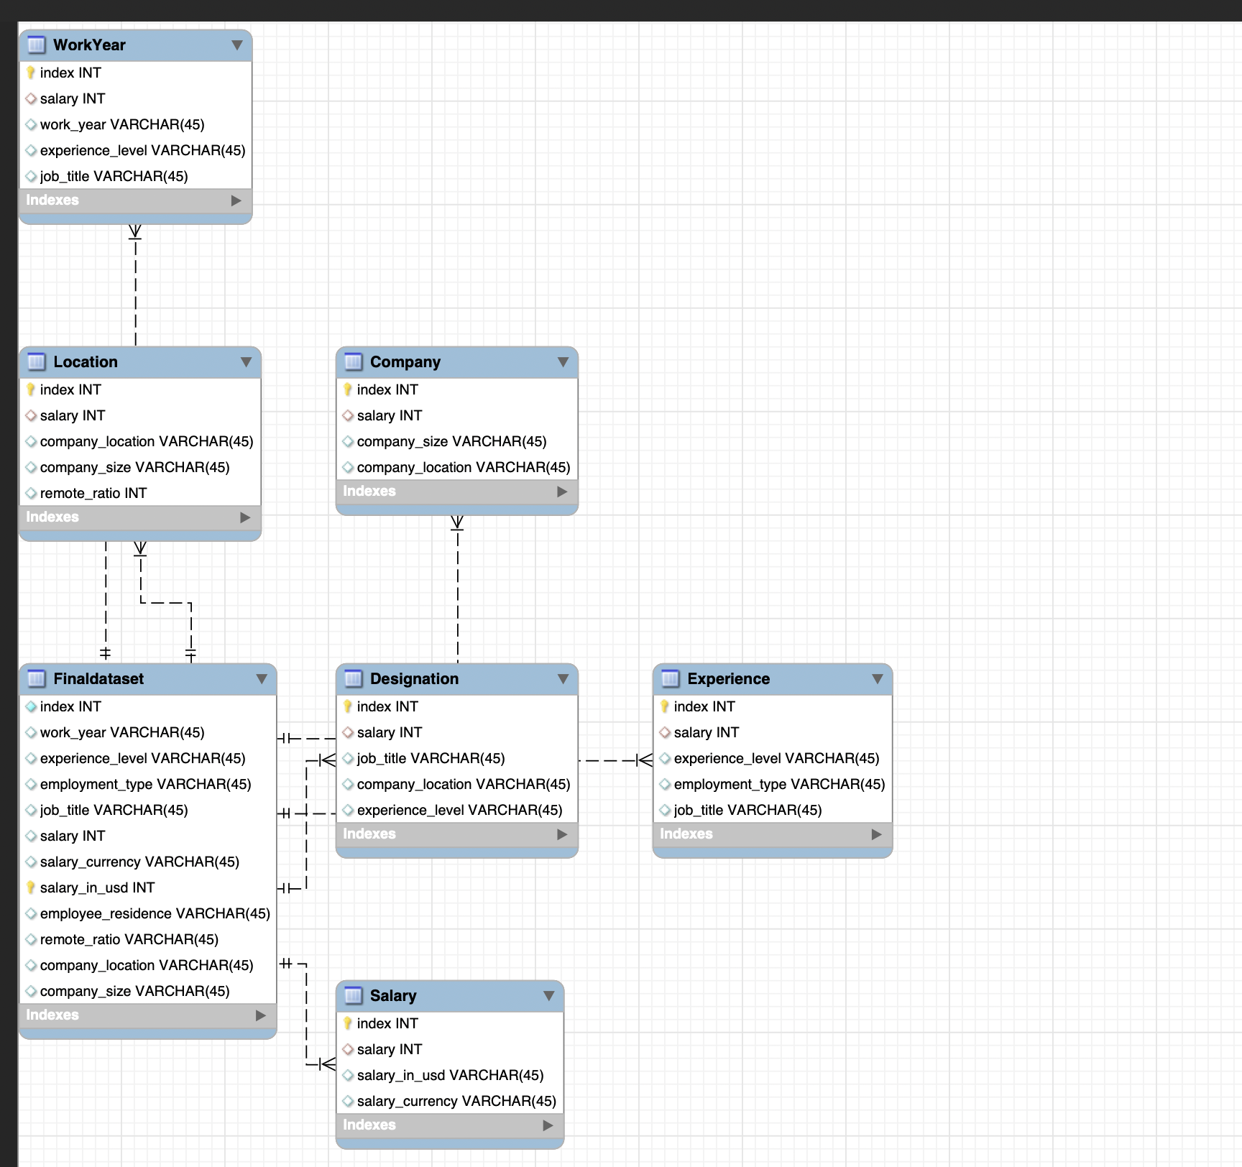

Database Screenshots of Normalized database :

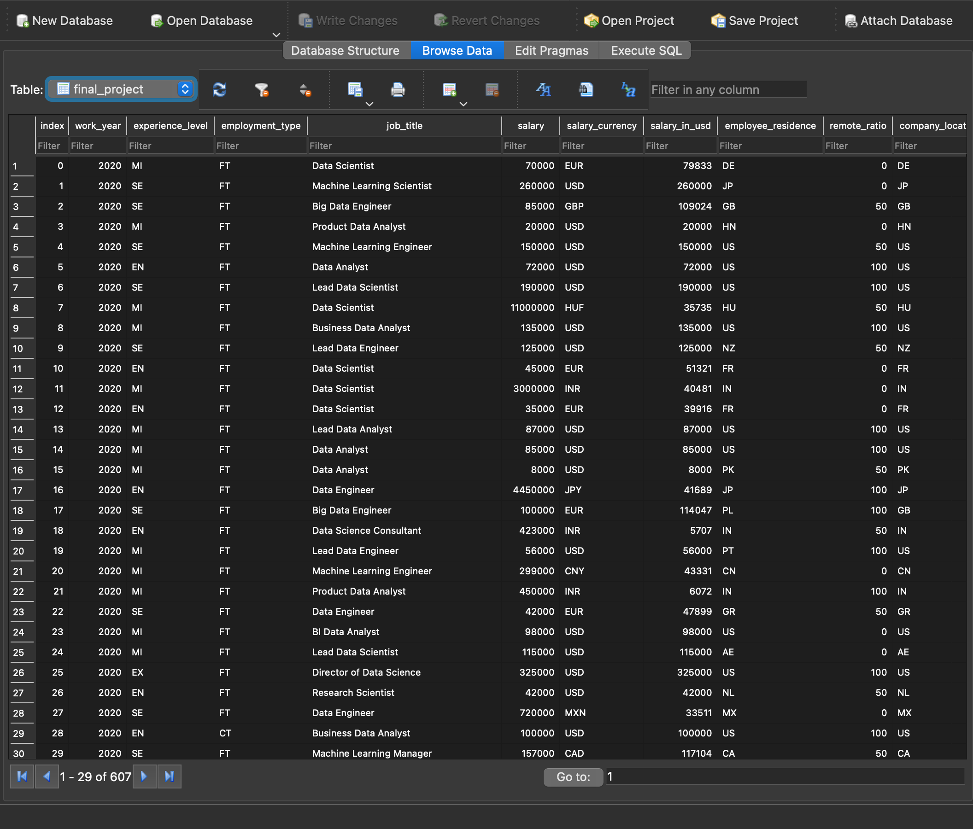

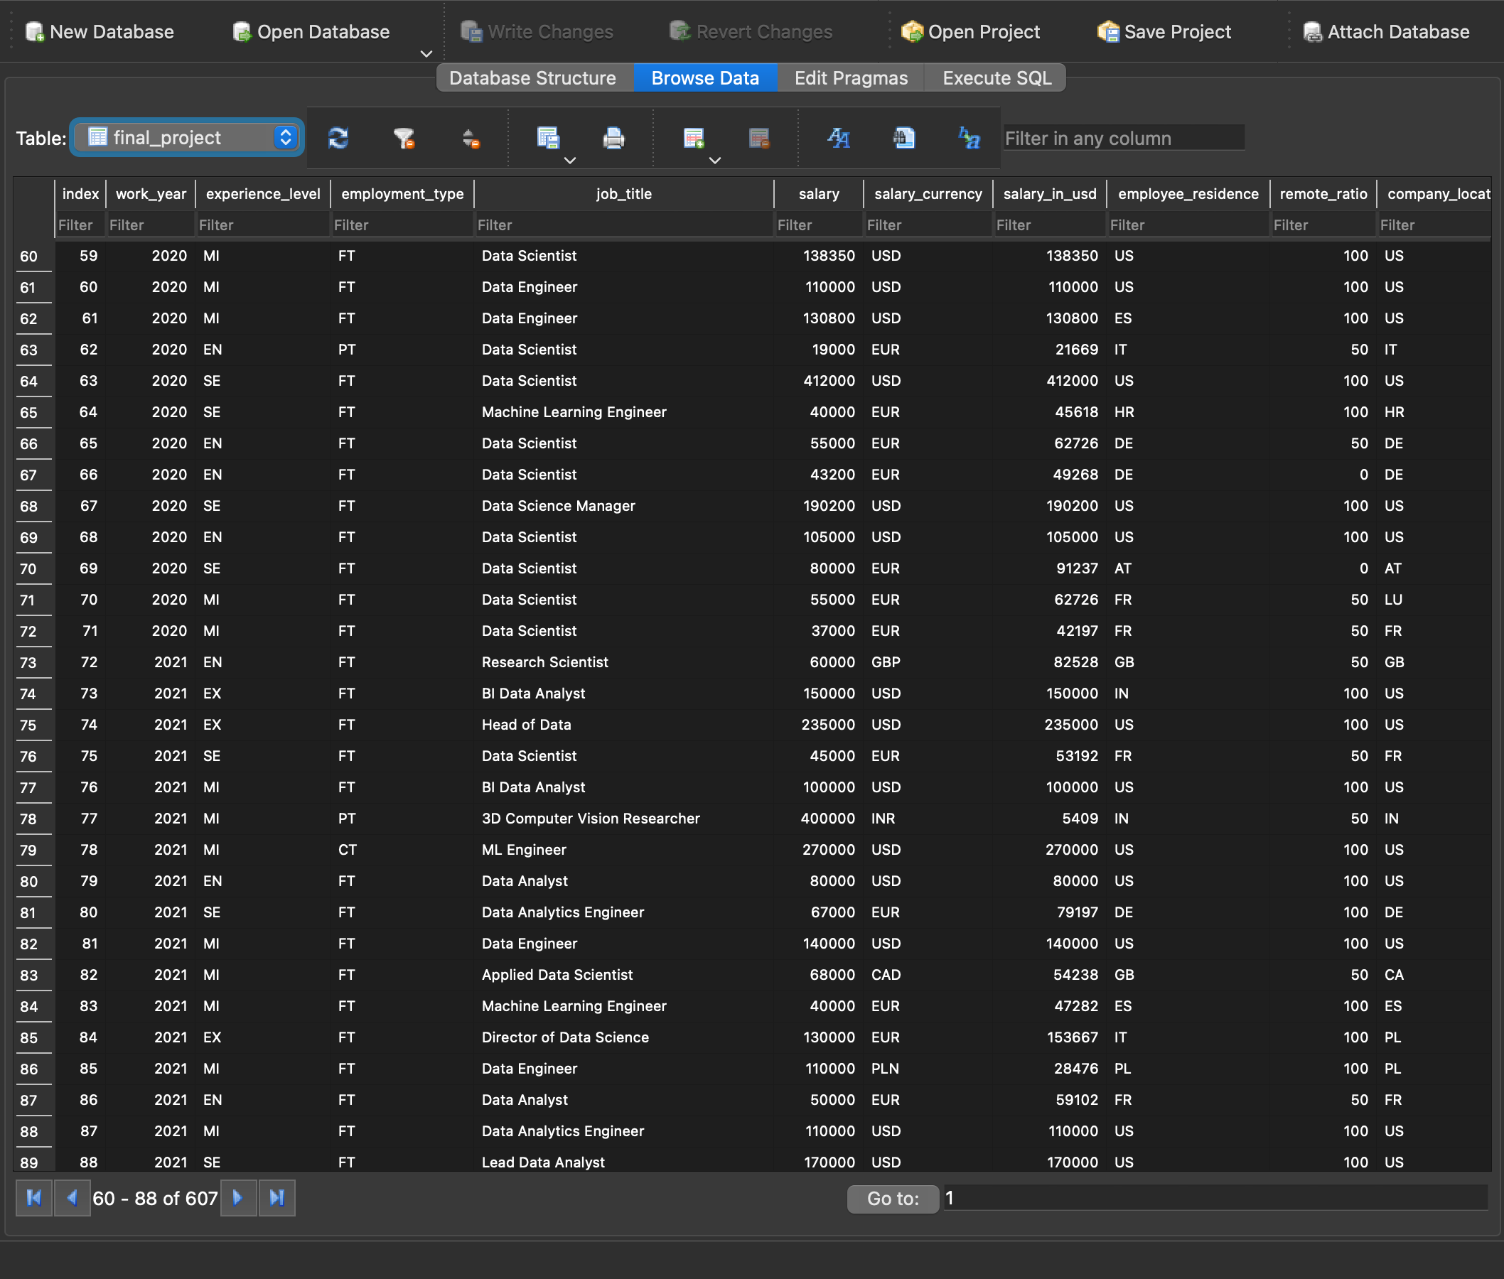

CREATE STATEMENT FOR FINAL DATABASE TABLE WHICH IS USED FOR CONCEPTUAL ER DIAGRAM :



MAJOR USE CASES SCREENSHOTS FROM JUPYTER NOTEBOOK:

1) df33 = pd.read_sql_query('select c.Company,o.Jobtype from InitialScraping_1 c inner join DMDD_Assignment3 o on c.Company = o.Company',con = conn )

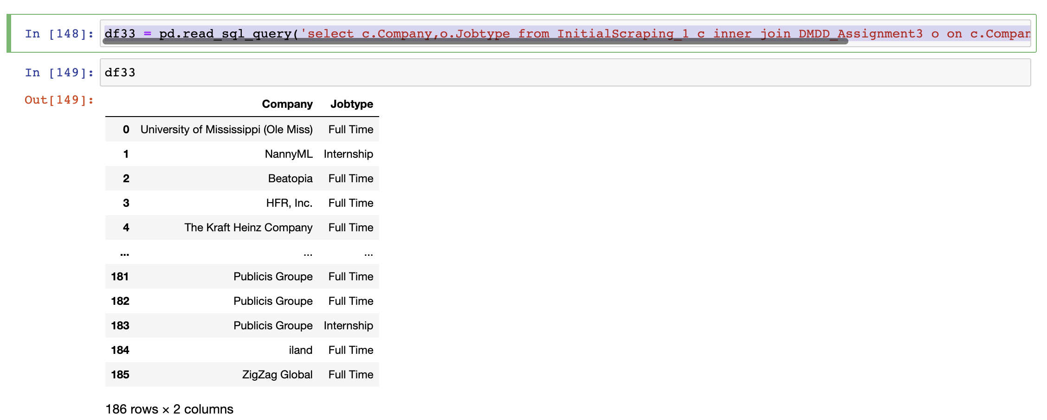

2) df34 = pd.read_sql_query('select c.Jobtype,o.Level from InitialScraping_1 c left join DMDD_Assignment3 o on c.Company= o.Company ORDER BY c.Level', con = conn )

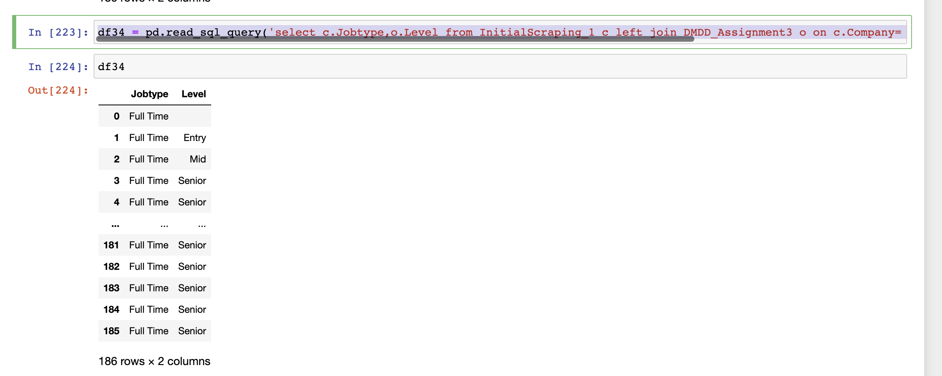

3) df35= pd.read_sql_query('select c.Jobtype,o.Location from InitialScraping_1 c right join DMDD_Assignment3 o on c.Company= o.Company ORDER BY c.Location',con = conn )

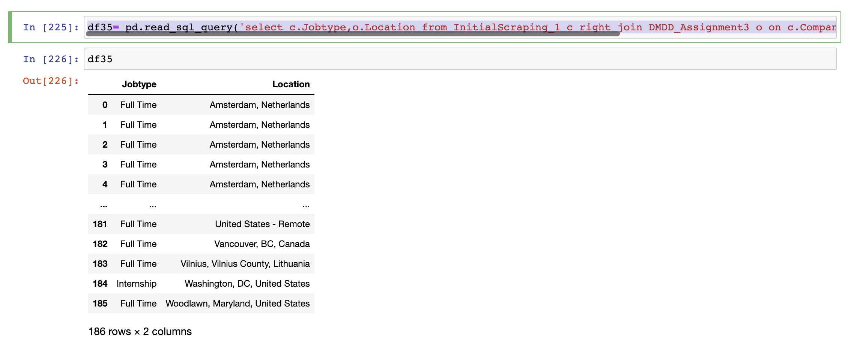

4) df36 = pd.read_sql_query('select c.Jobtype,o.Company from InitialScraping_1 c full outer join DMDD_Assignment3 o on c.Jobtype= o.Jobtype ORDER BY c.COmpany',con = conn )

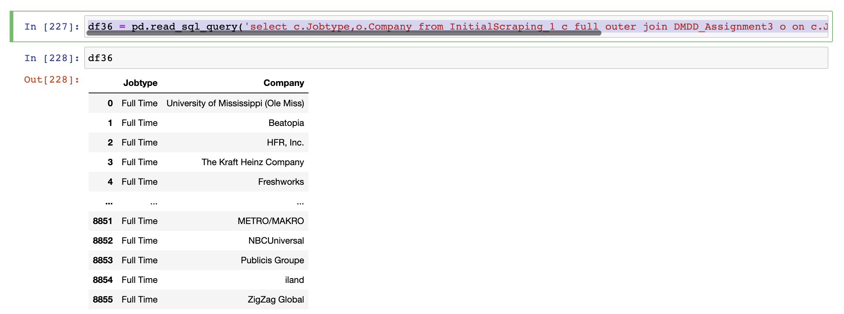

5) df37 = pd.read_sql_query('select c.Level,c1.Company from InitialScraping_1 c, InitialScraping_1 c1 where c.Jobtype= c1.Jobtype',con = conn )

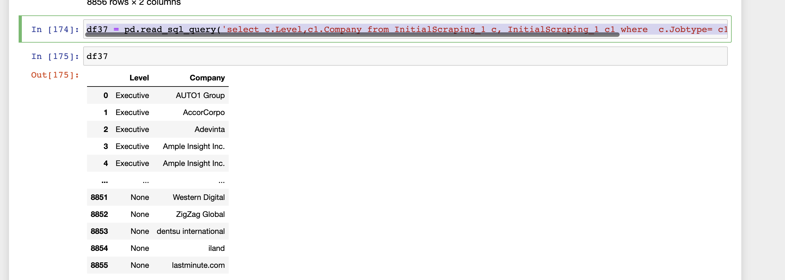

6) df38 = pd.read_sql_query('select c.job_title,c1.salary from Scraping3_1 c, Scraping3_1 c1 where c.salary= c1.salary',con = conn )

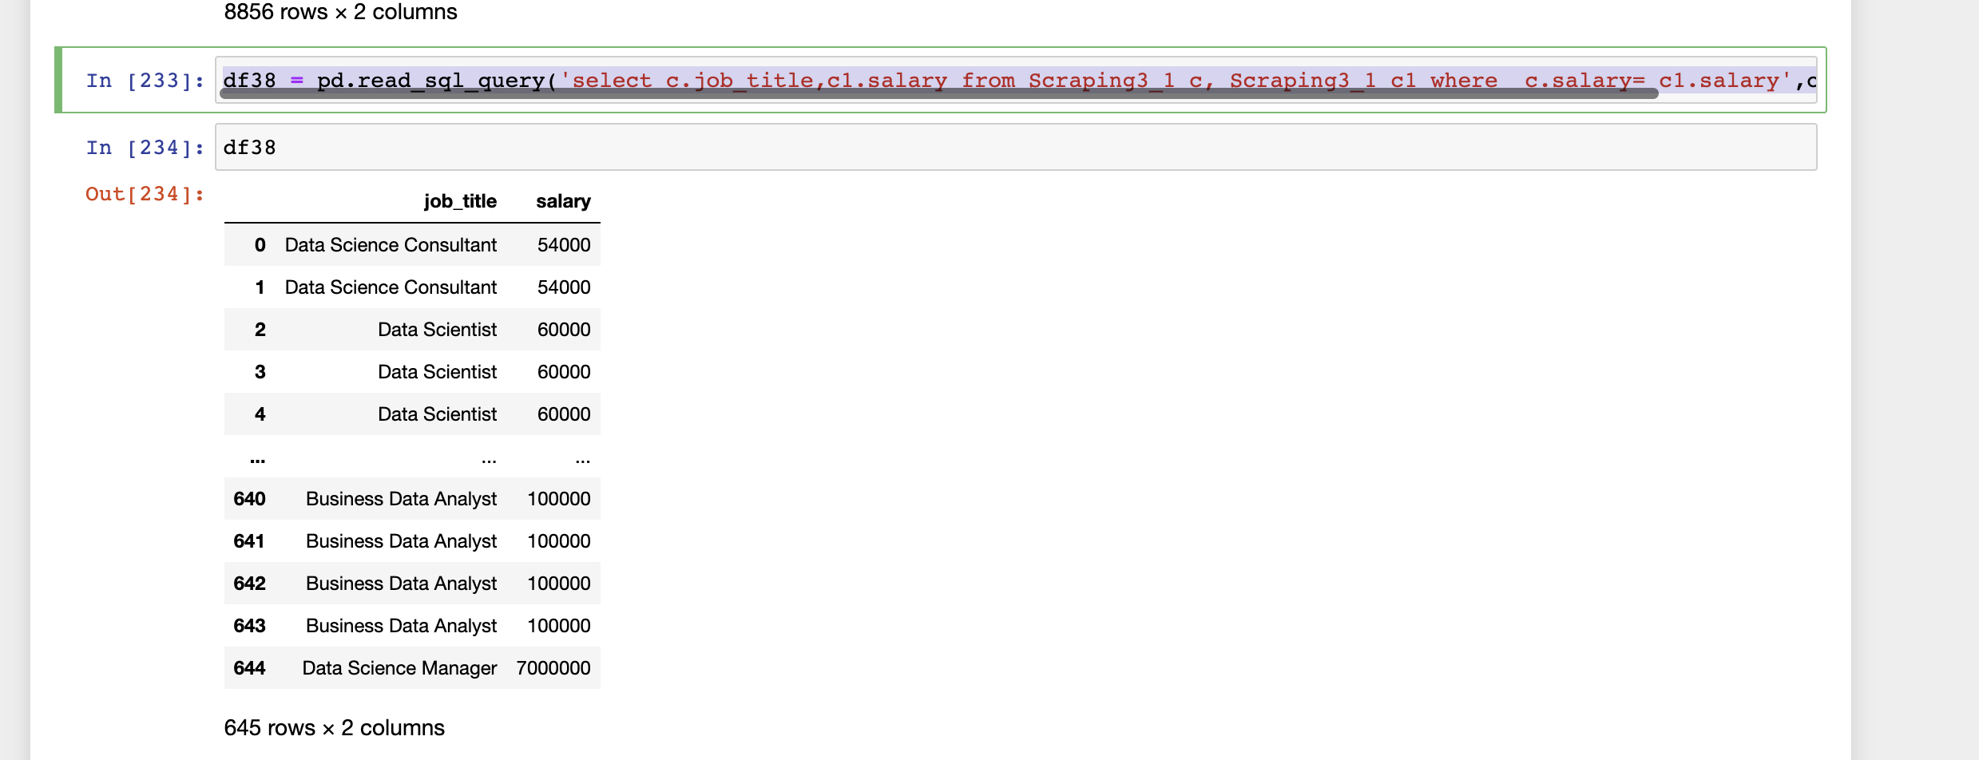

7) df39 = pd.read_sql_query('select c.experience_level,c1.employment_type, c1.employee_residence from Scraping3_1 c, Scraping3_1 c1 where c.salary= c1.salary',con = conn )

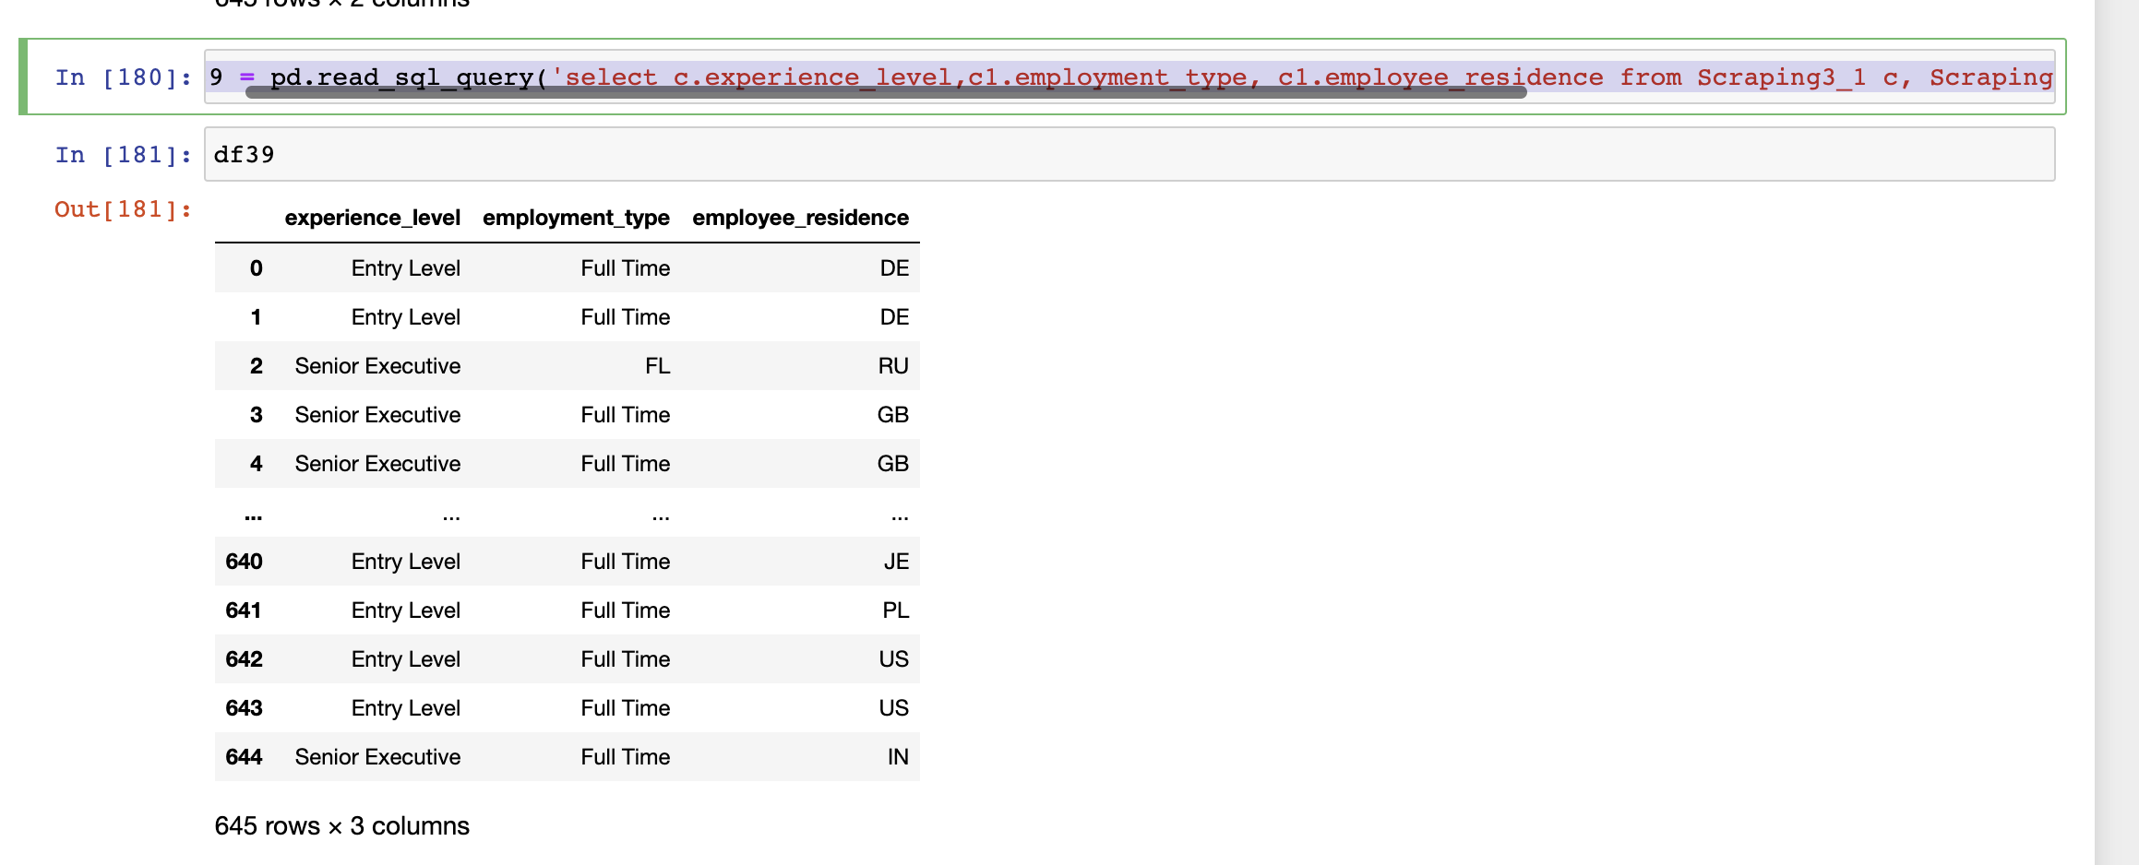

8) df40 = pd.read_sql_query('select c.Position,c1.Company, c1.Jobtype from WEBSC_2_1 c, WEBSC_2_1 c1 where c.Position = c1.Position ',con = conn )

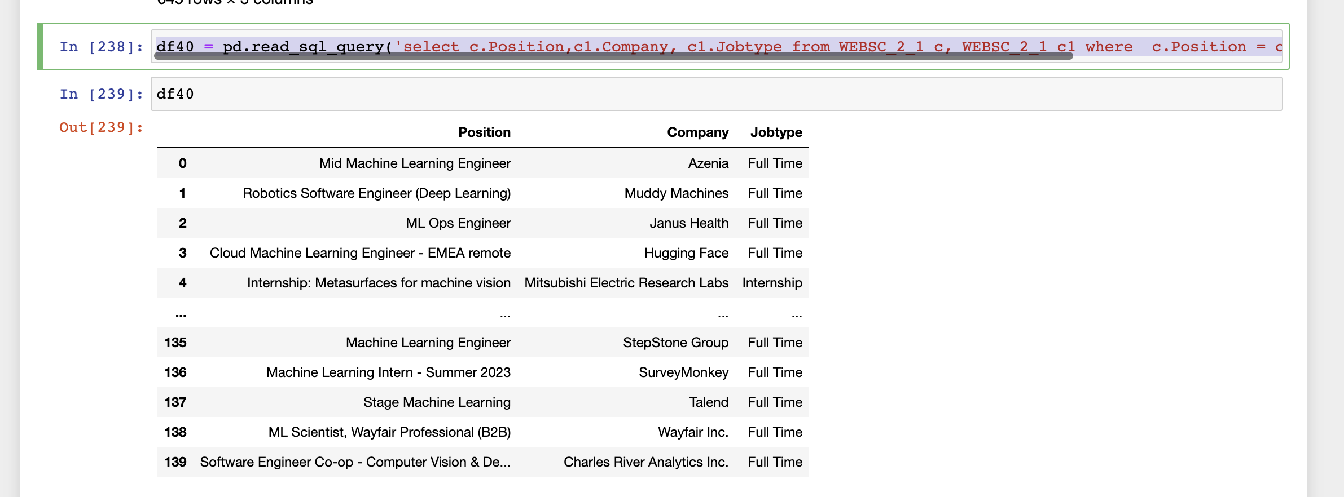

9) df41 = pd.read_sql_query('select c.Jobtype,o.Summary from InitialScraping_1 c left join DMDD_Assignment3 o on c.Company= o.Company',con = conn )

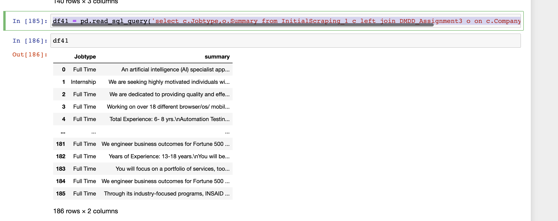

10) df42= pd.read_sql_query('select c.Company,o.Salary from InitialScraping_1 c right join DMDD_Assignment3 o on c.Company= o.Company',con = conn )

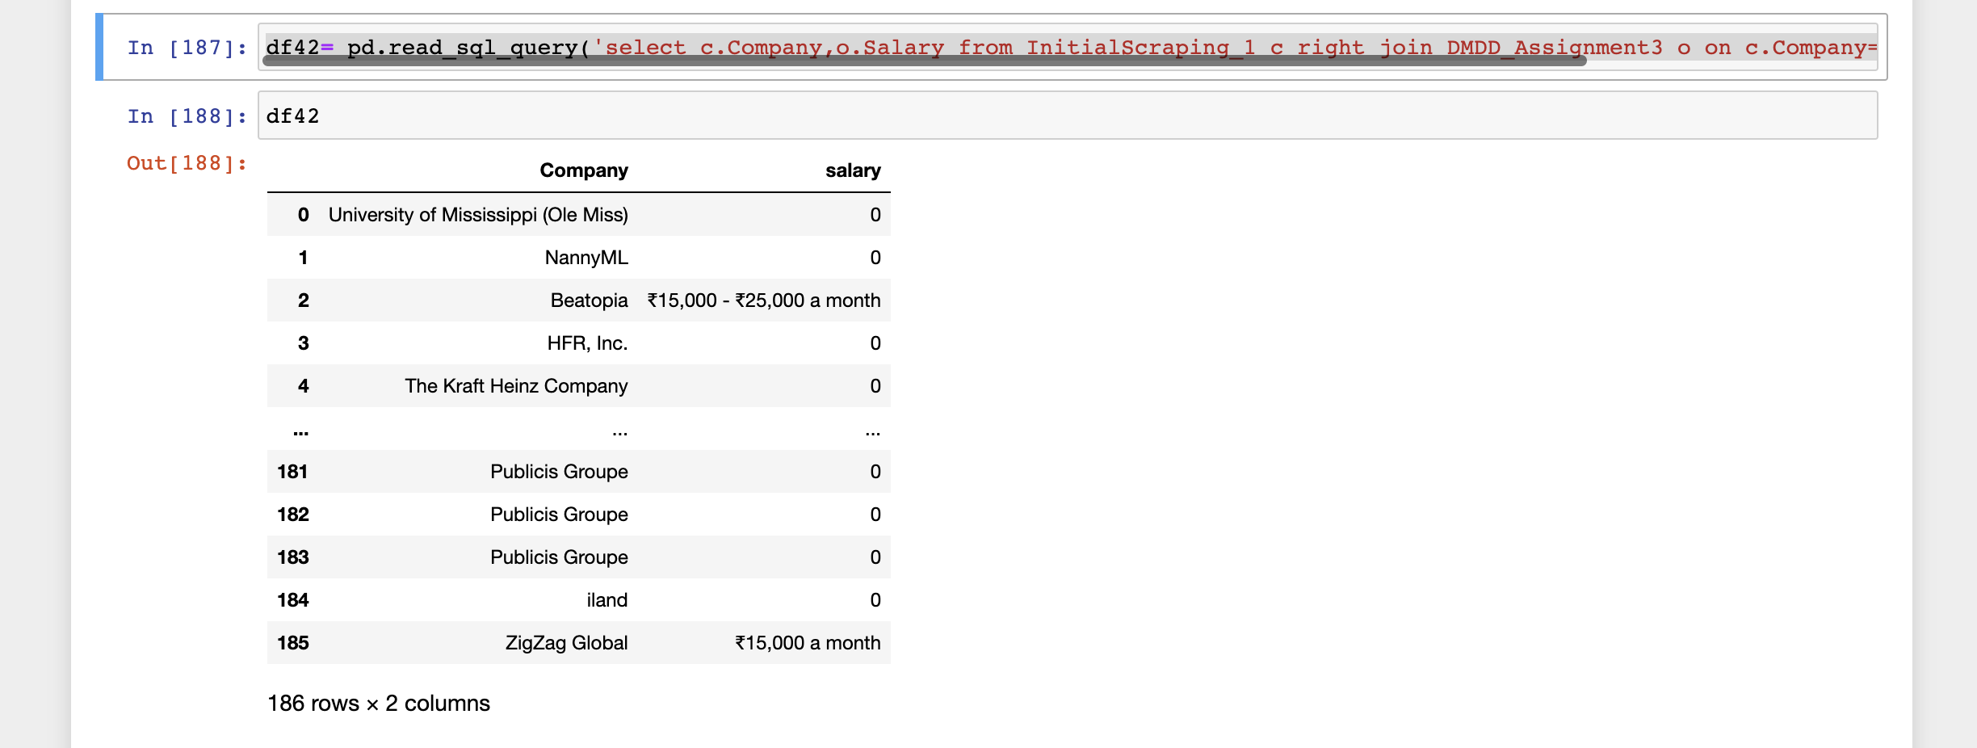

DATA VISUALIZATION DONE IN FINAL DMDD PROJECT :

1) Graph for co - relation of columns

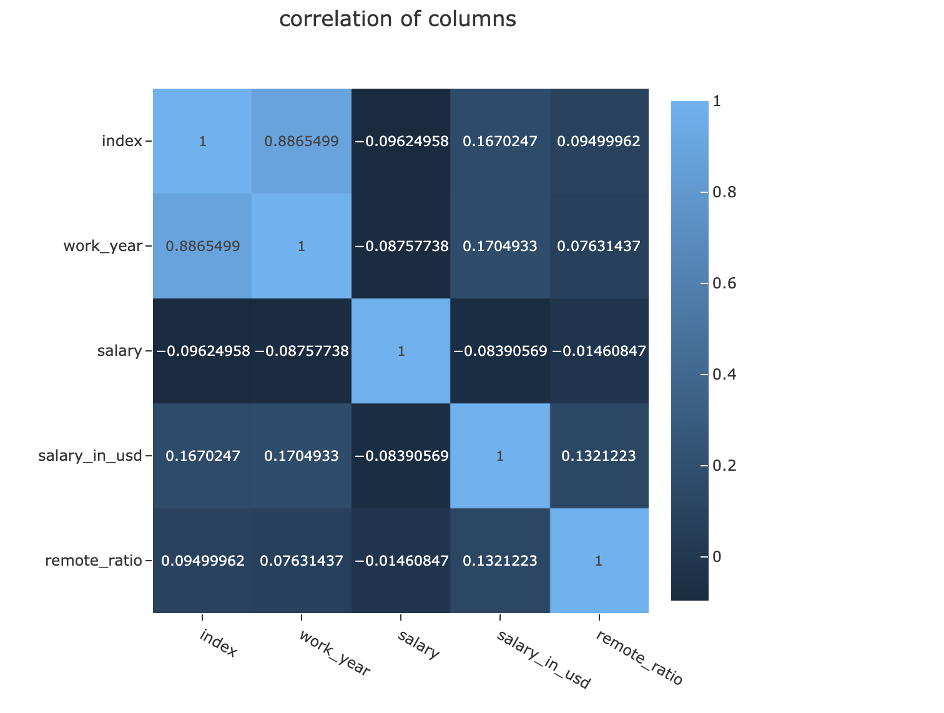

2) Graph for Top 10 Popular Data Science Roles

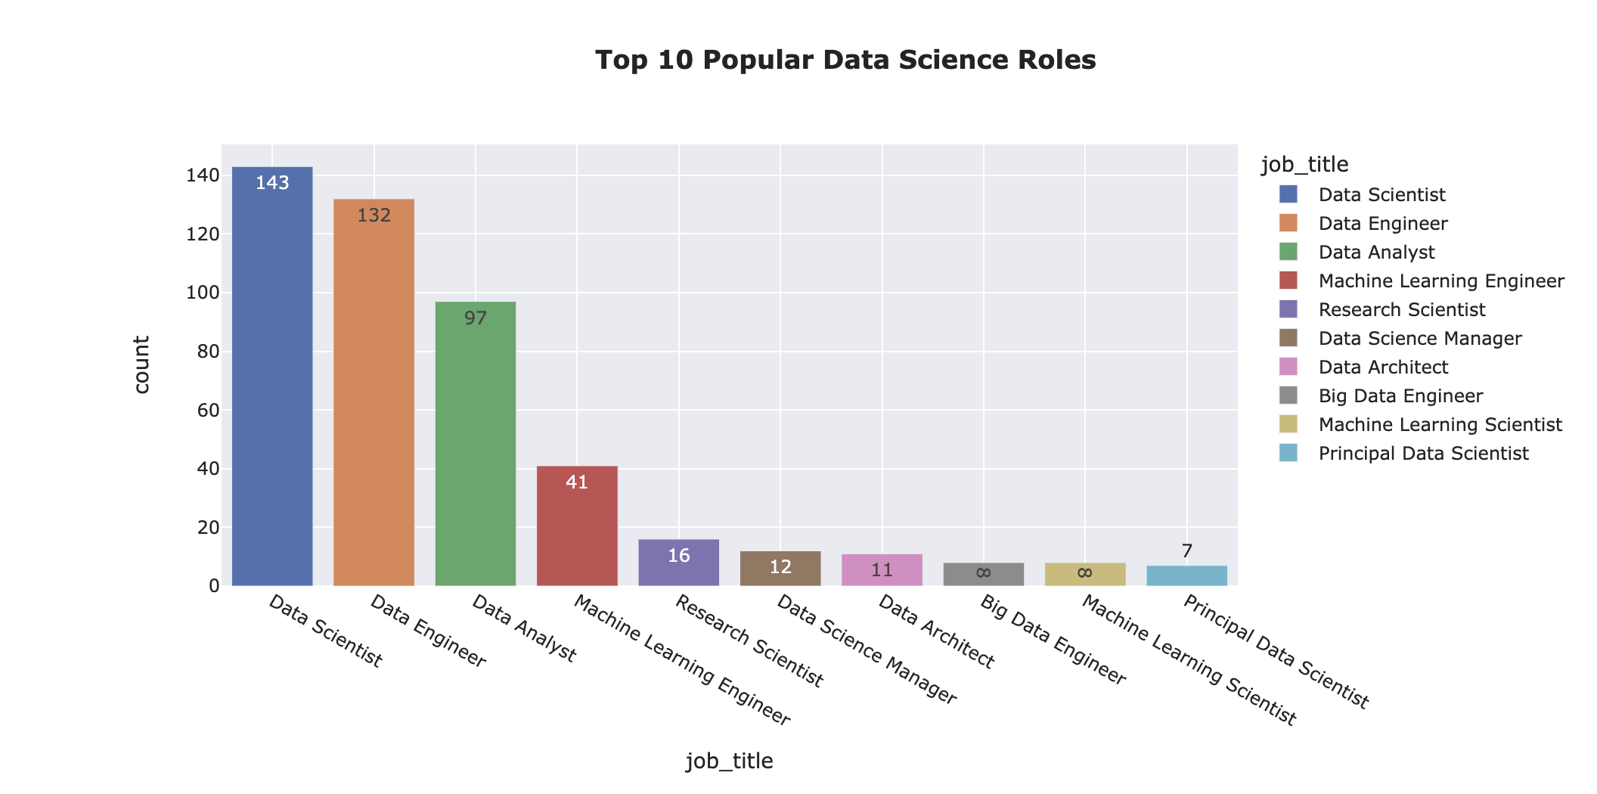

3) Graph for Top 10 Roles in Data Science based on Average Pay

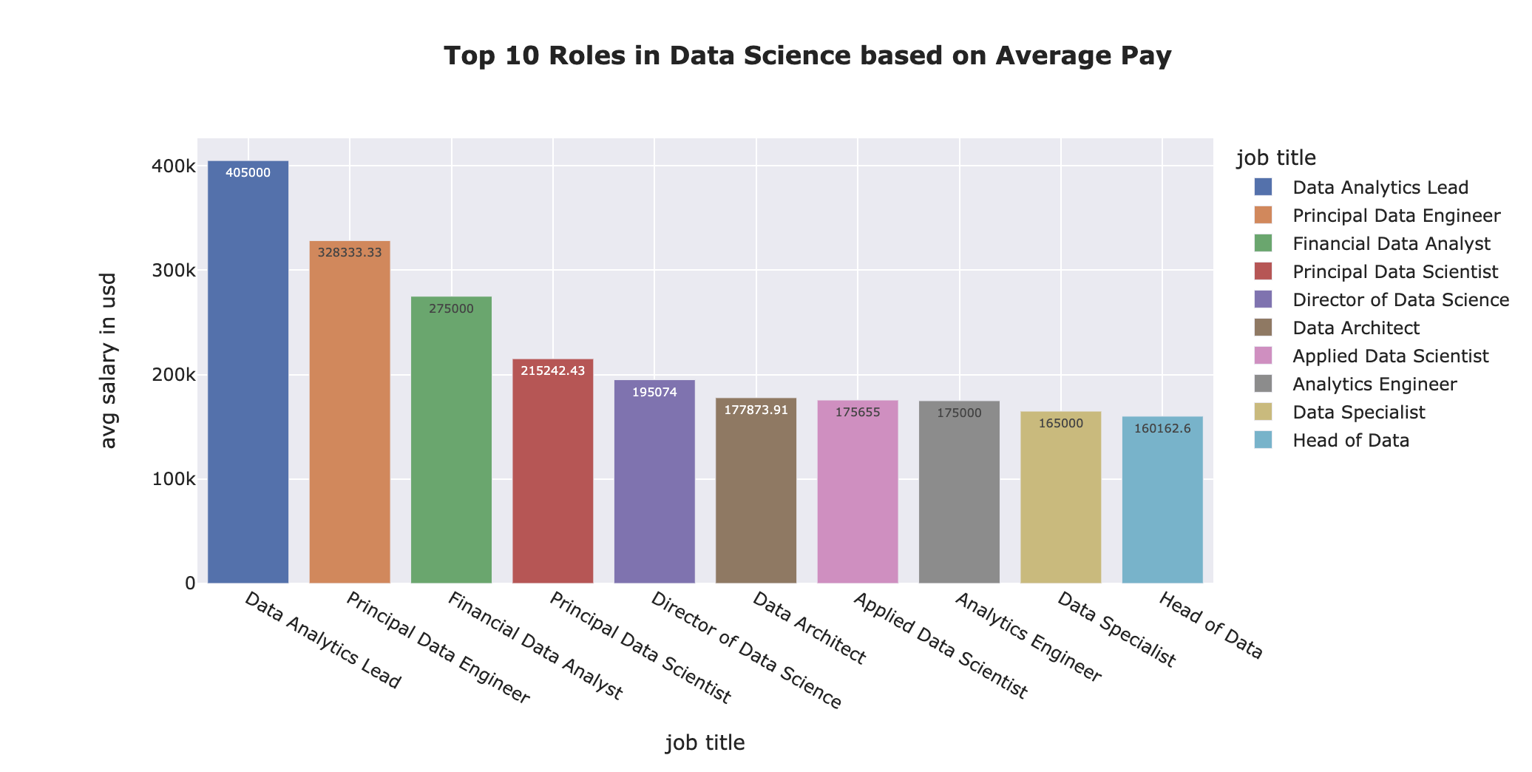

4) Pie Chart for total jobs based per year

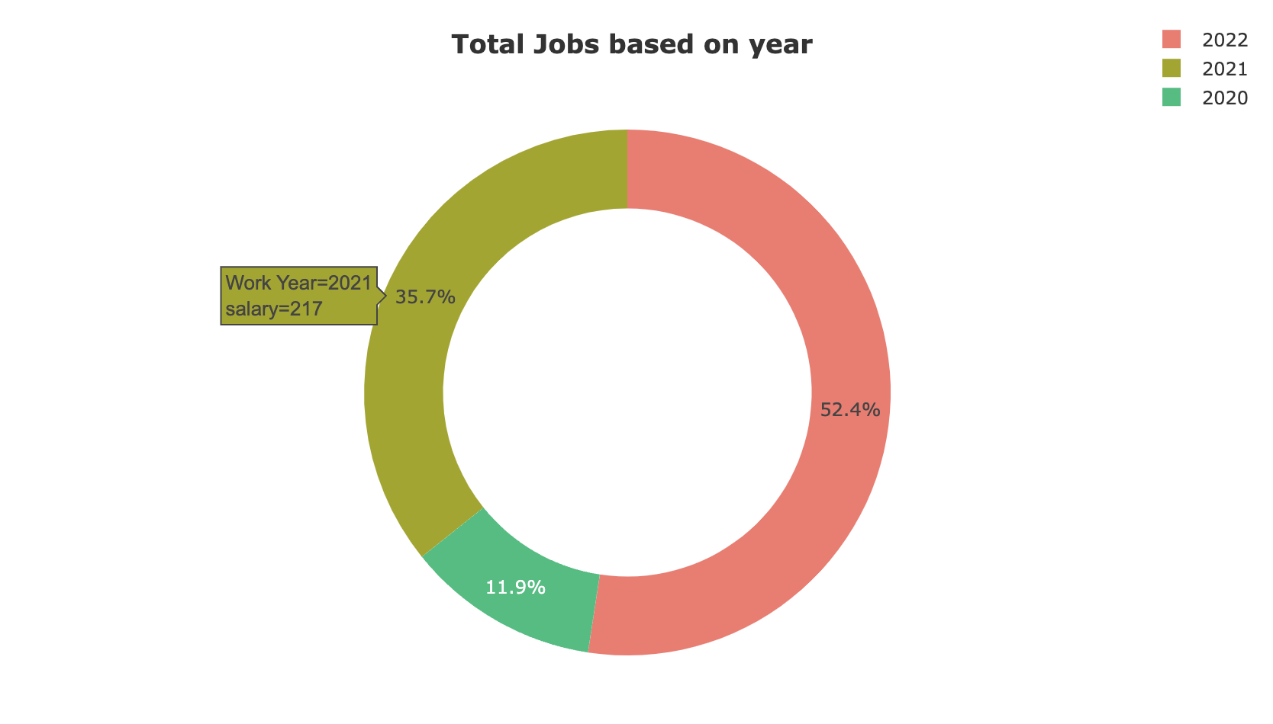

5) Pie Chart for company sizes in Data Science Field

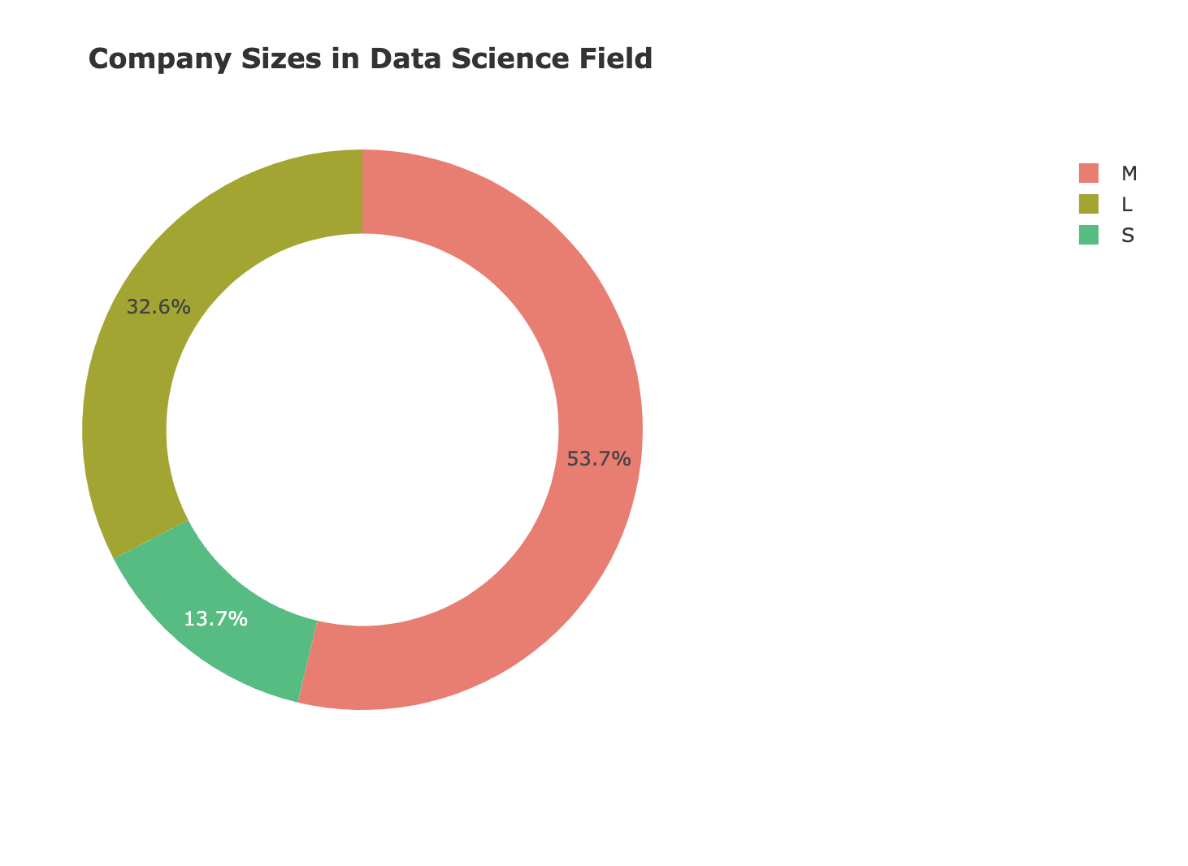

6) Histogram for Salary Distribution

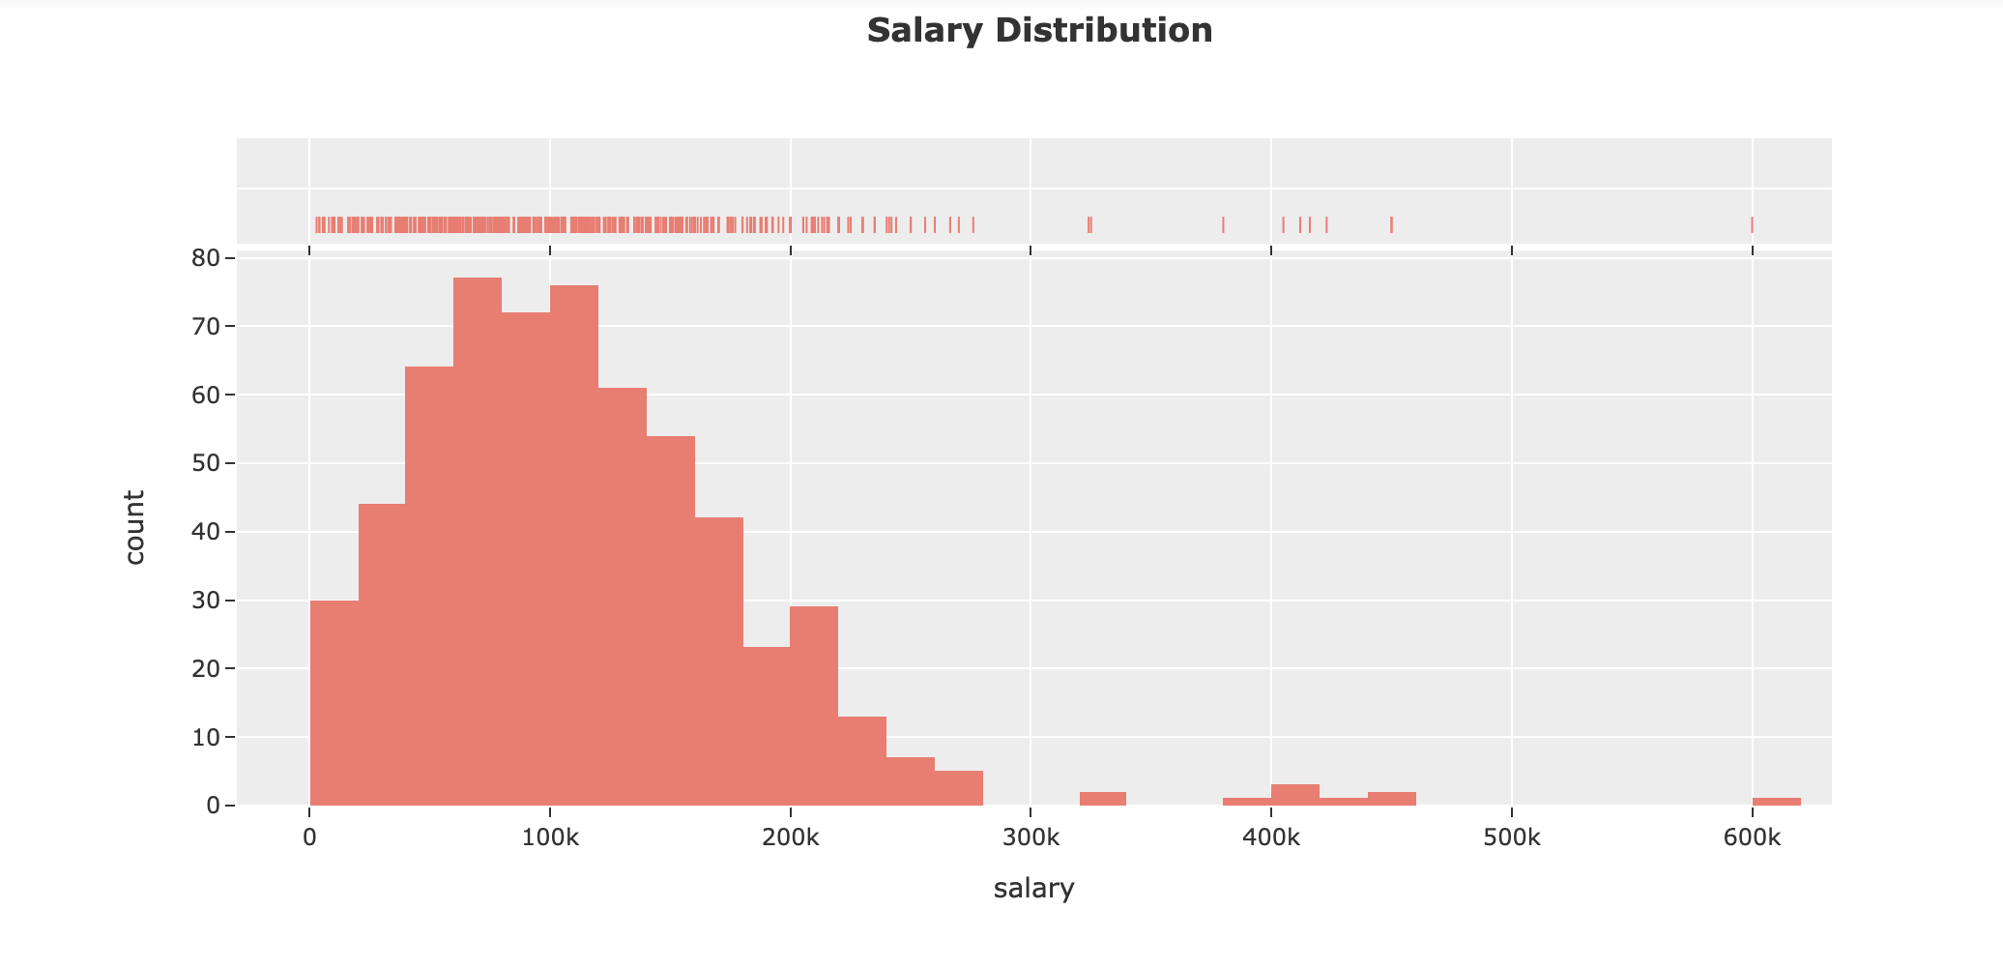

7) Violin Graph for Data Science Salaries by year

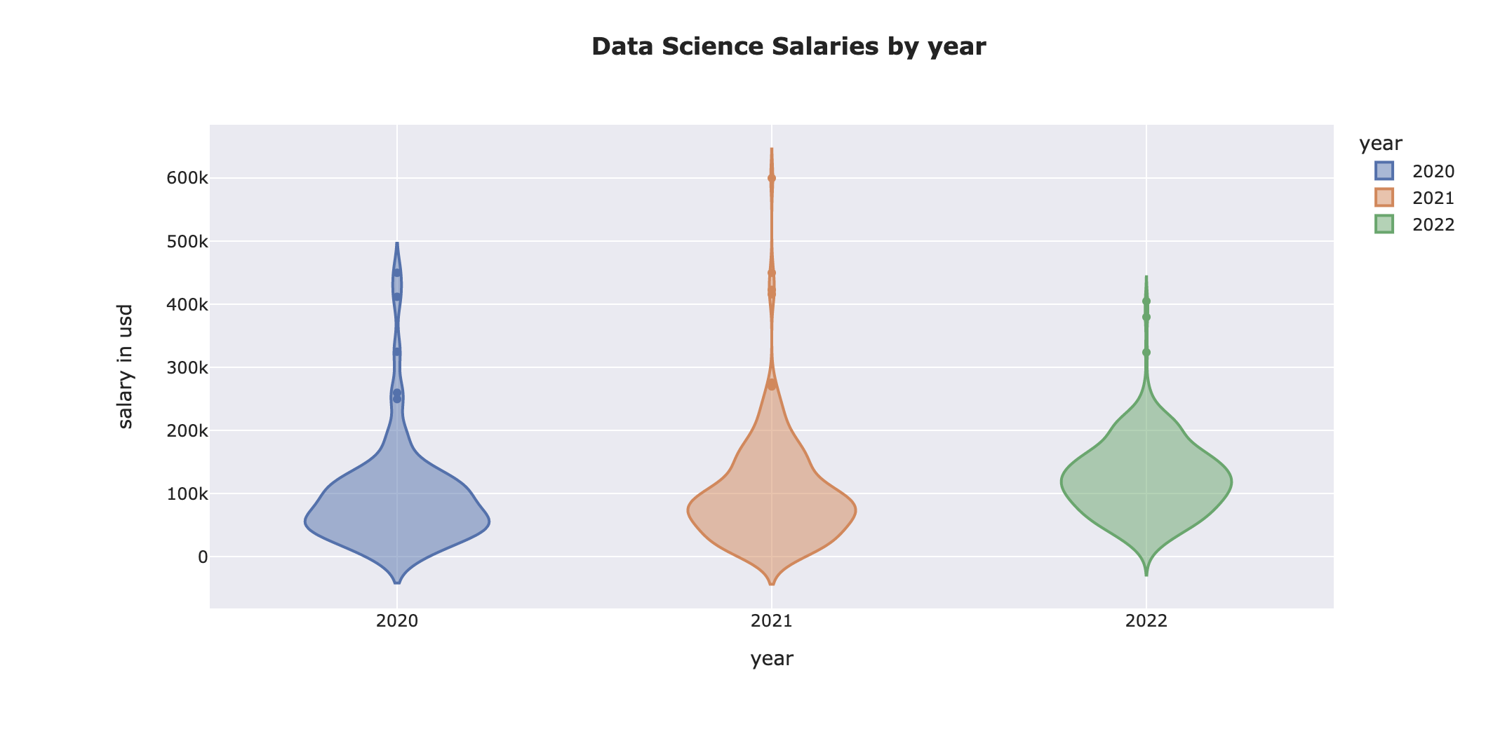

8) BoxPlot for Data Science Salaries by experience.

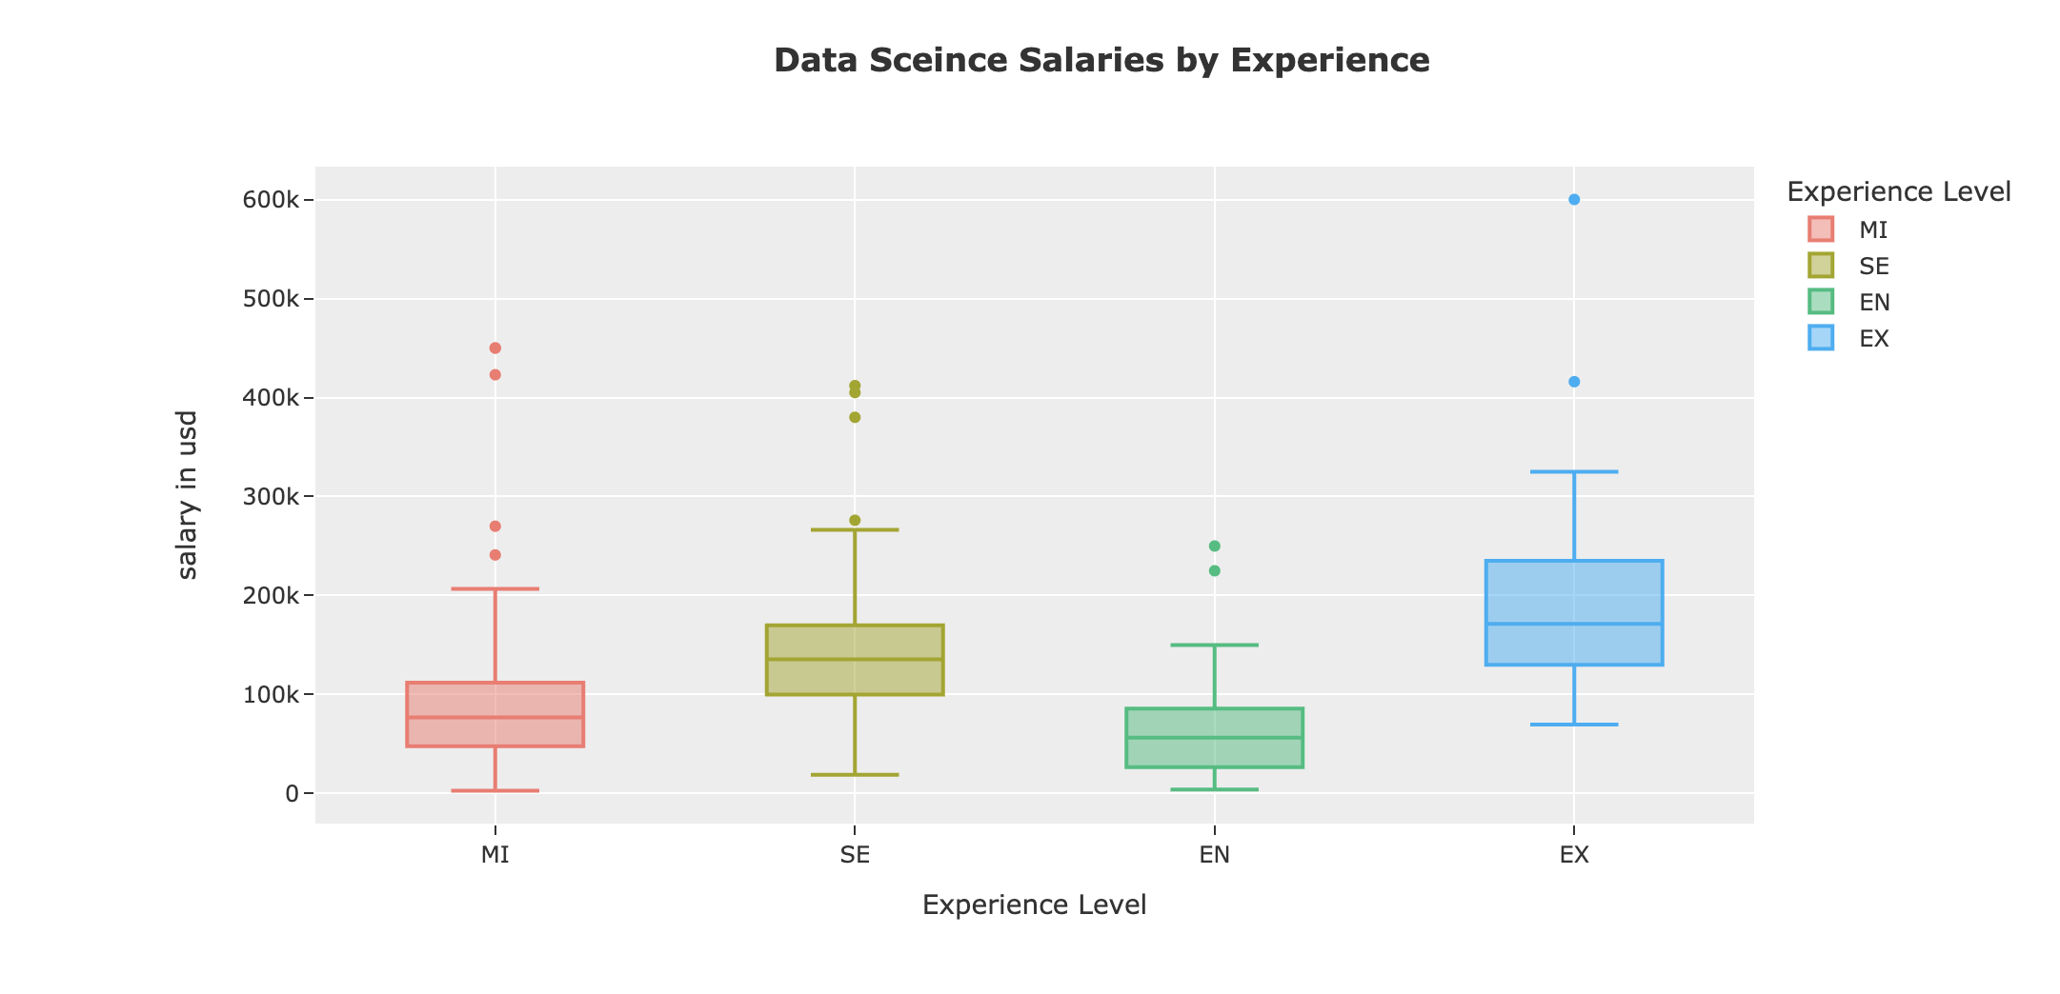

9) Box Plot for Data Science Salaries by type of employee

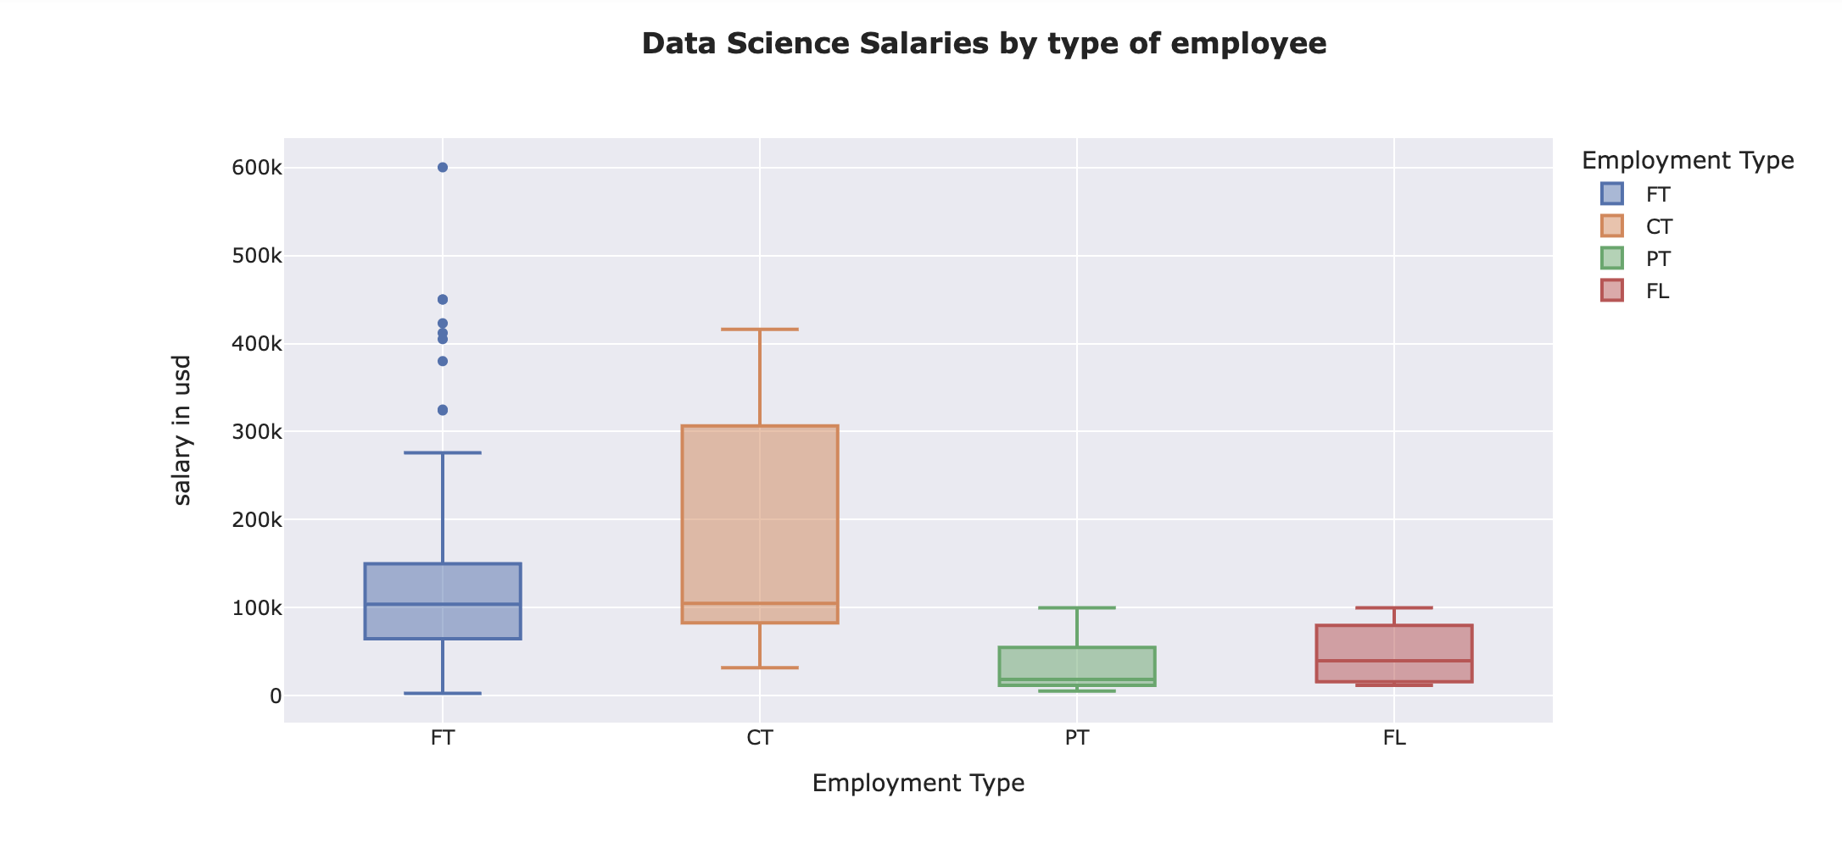

10 ) Box Plot for Data Science Salaries by company size

